**LINUX AND CLOUD COMPUTING**

Name: Sanika Utturwar

Roll No.: 240840325048

**LINUX:**

**QUES 1.**

**QUES 2.**

1. mkdir new_dir

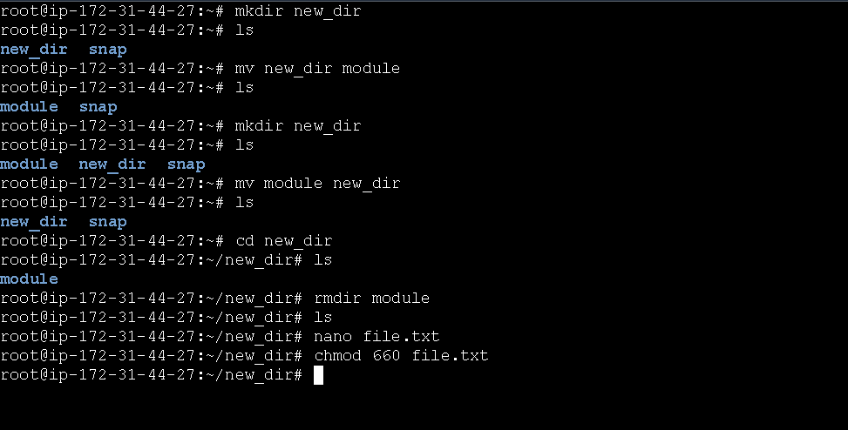

1. **mv new_dir module**



1. **create directory new_dir then**

**mv module new_dir**



1. **rmdir module**



1. **nano file.txt**

**chmod 660 file.txt**



**AWS:**

1. **Create a new IAM user with Programmatic access, ensuring that the user has a policy granting EC2 Full Access**

Step 1. Login in to your AWS account

Step 2. Search for IAM. You will be redirected to IAM DashBoard

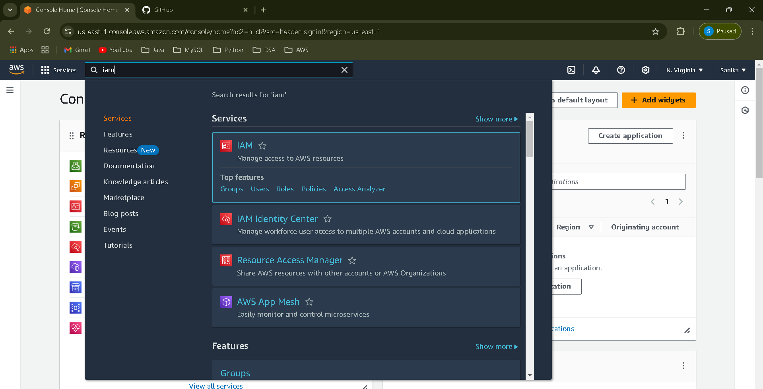

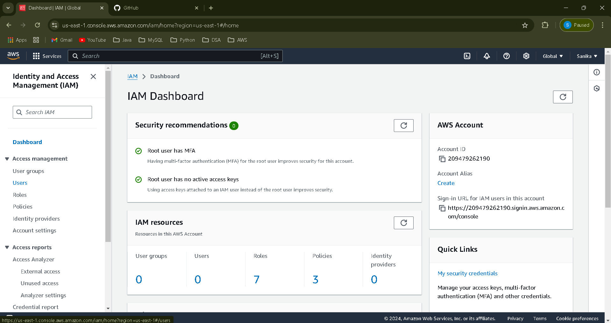

Step 3. Click on Users on left panel

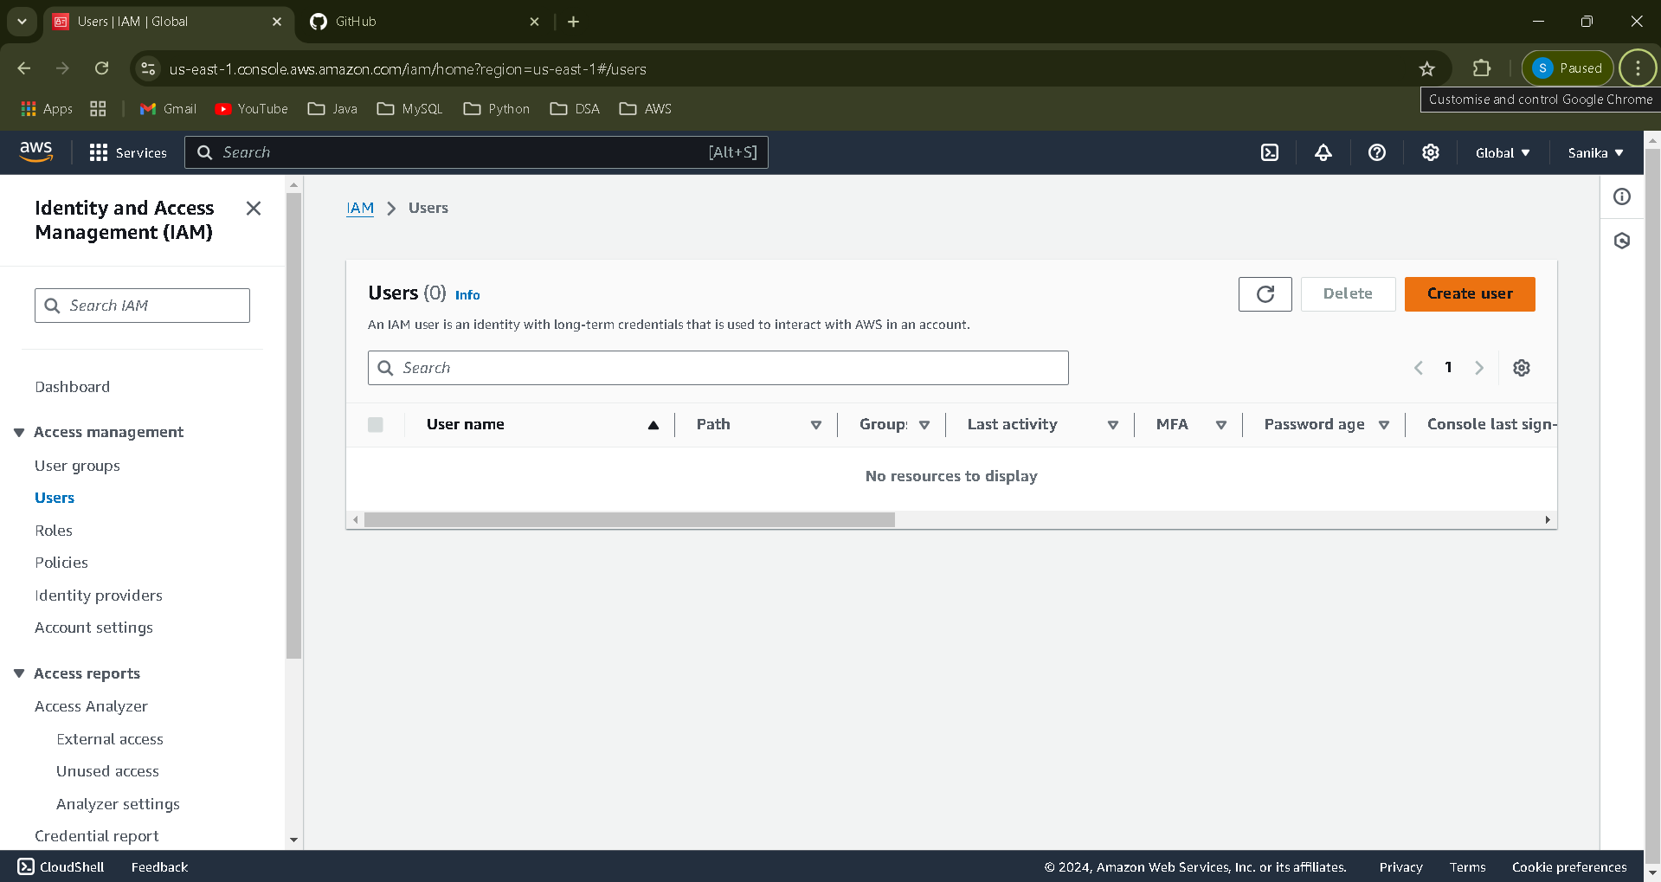

Step 4. Click on Create User. Provide User Name of your choice

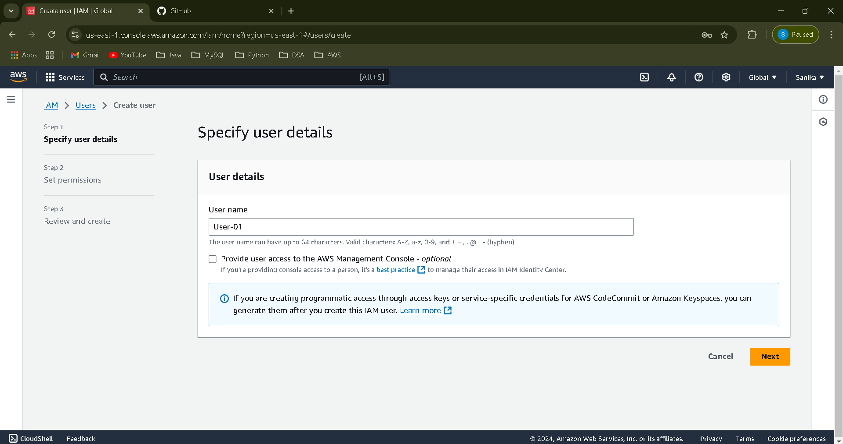

Click on next and then In set permission choose the option Attach policies directly

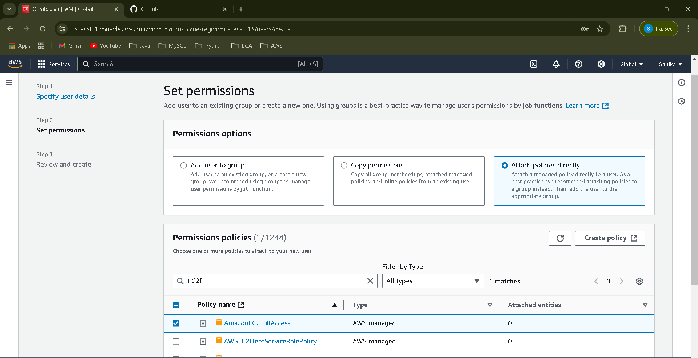

Step 5. Click on create user. Your User will be created. 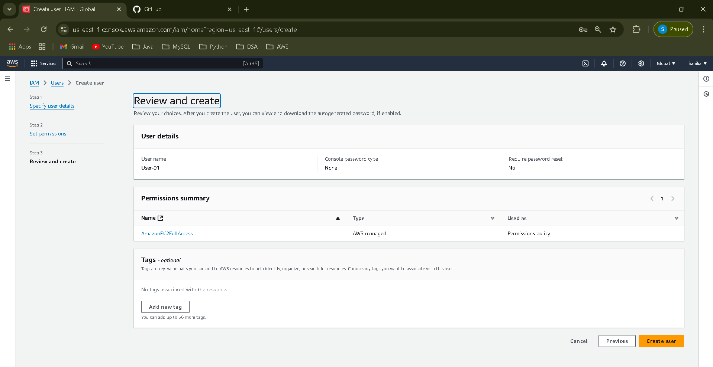

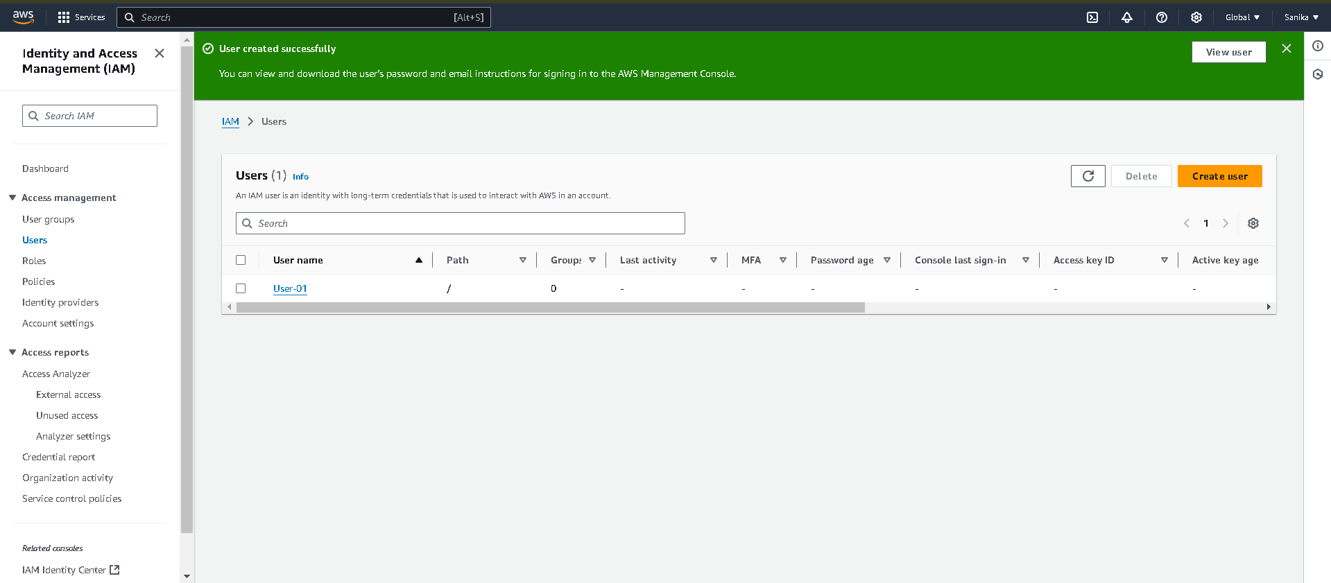

Hence, Your new user is created successfully.

**Ques. 2:**

Step 1. Click on User created recently.



Step 2. Click on Security Credentials. And Enable console access, Auto generate password and download .csv file for future use.

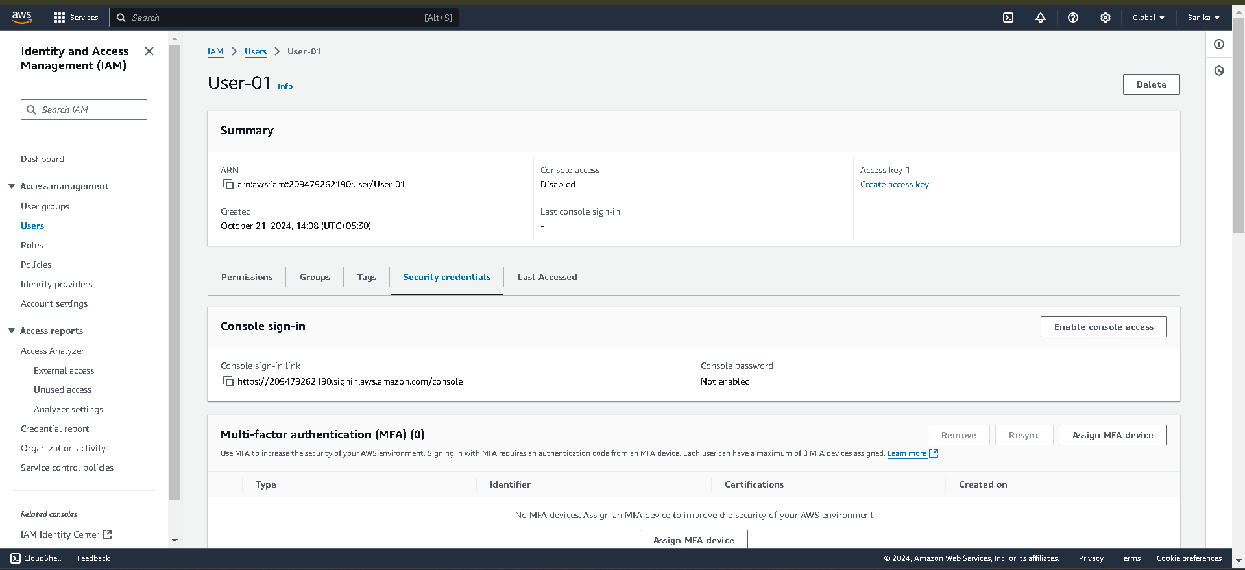

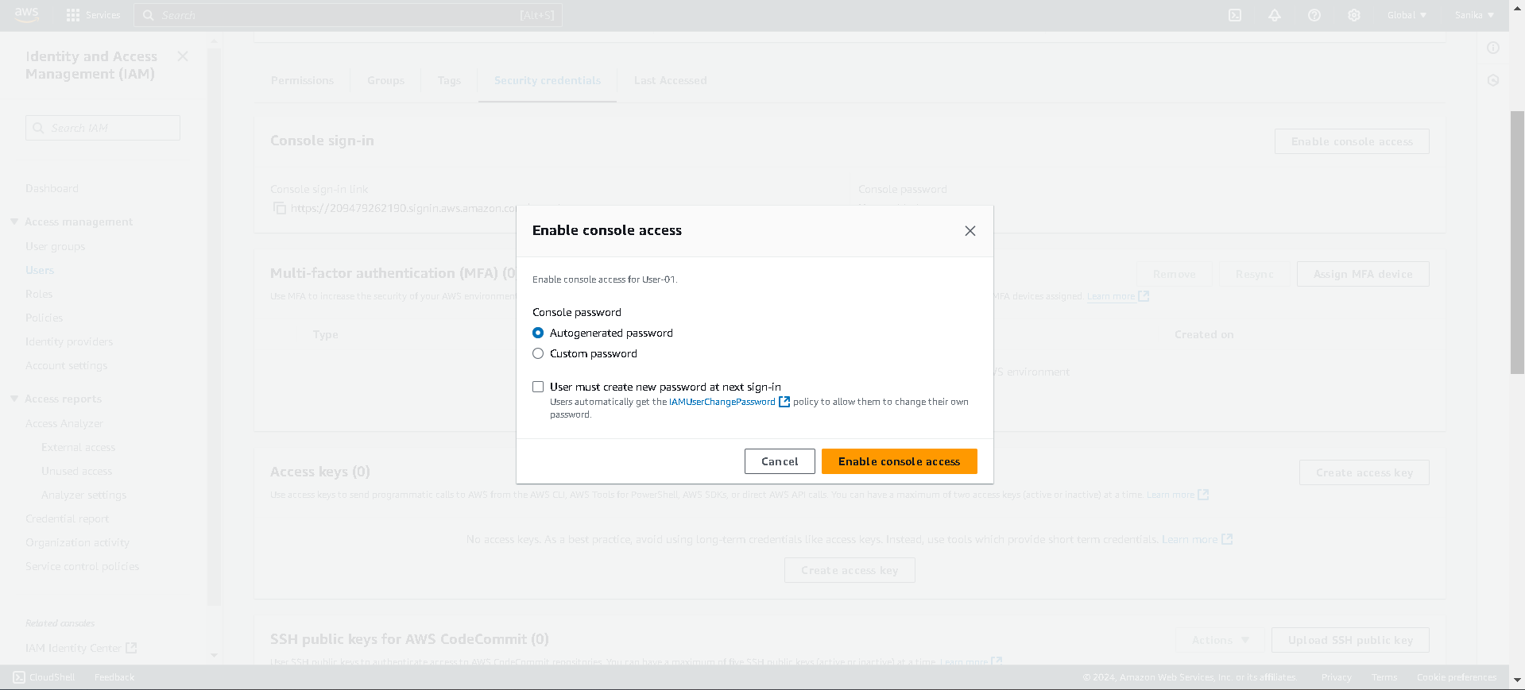

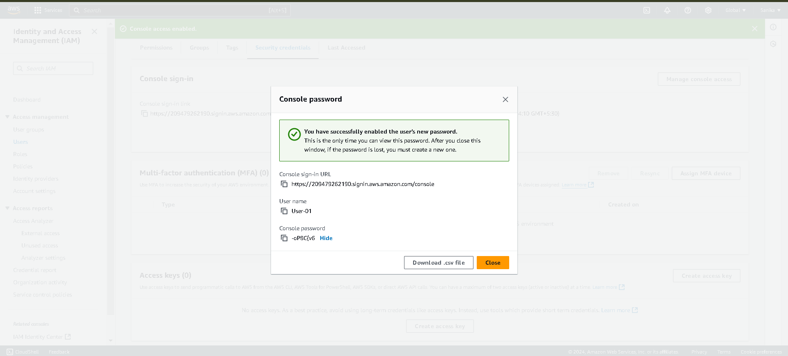

Step 3. With the help of console sign-in URL Login to the new IAM user created

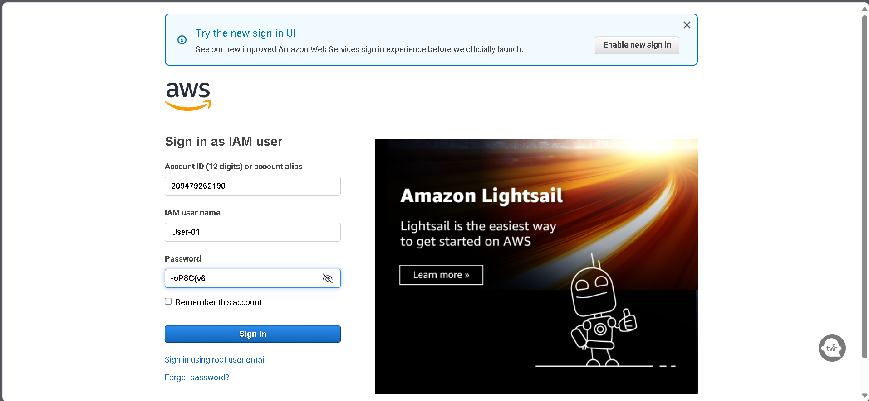

Step 4. After Login Search for EC2 for creating the instance

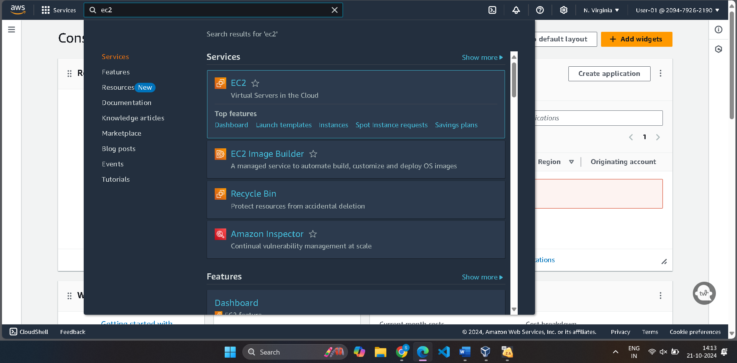

Step 5. Launch instance

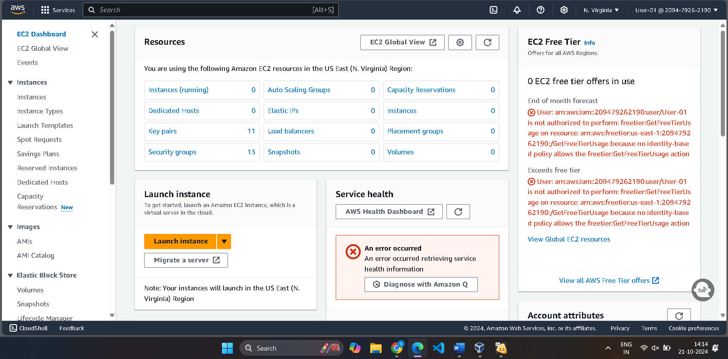

Step 6. Provide the necessary details Like name of the Instance, Select AMI as Amazon Linux 2023

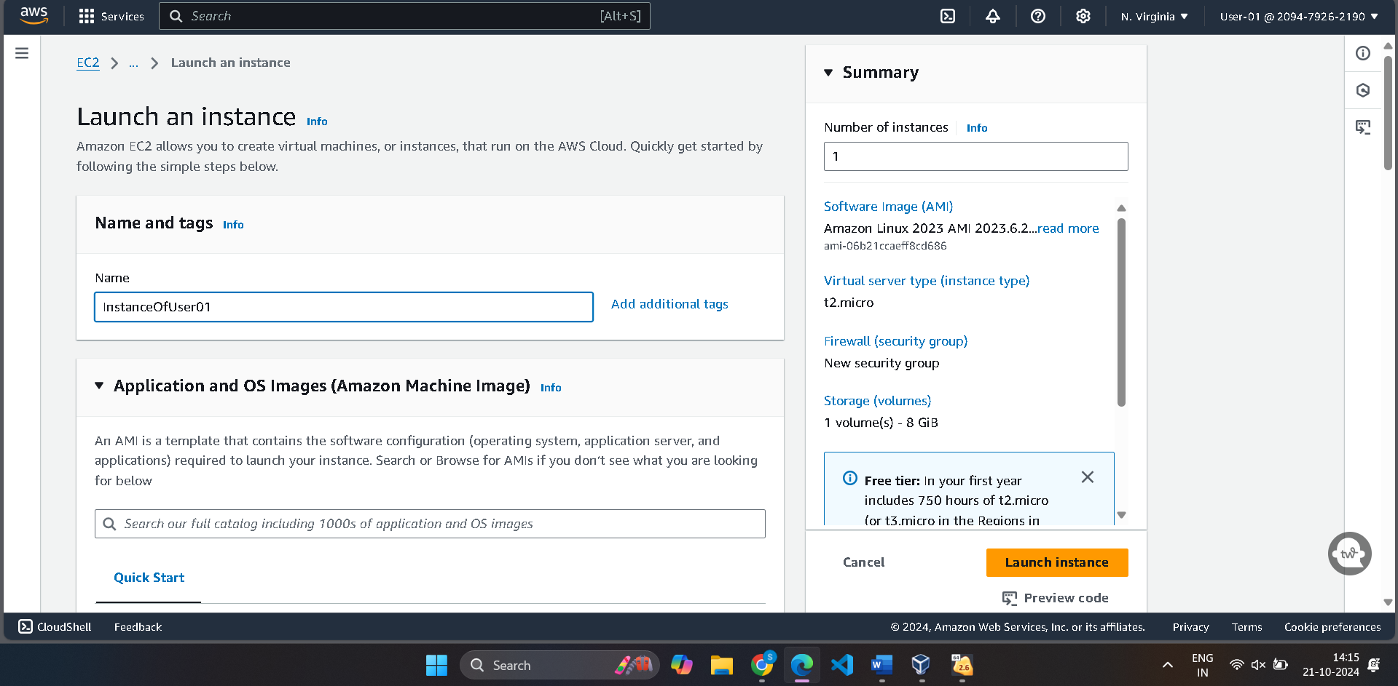

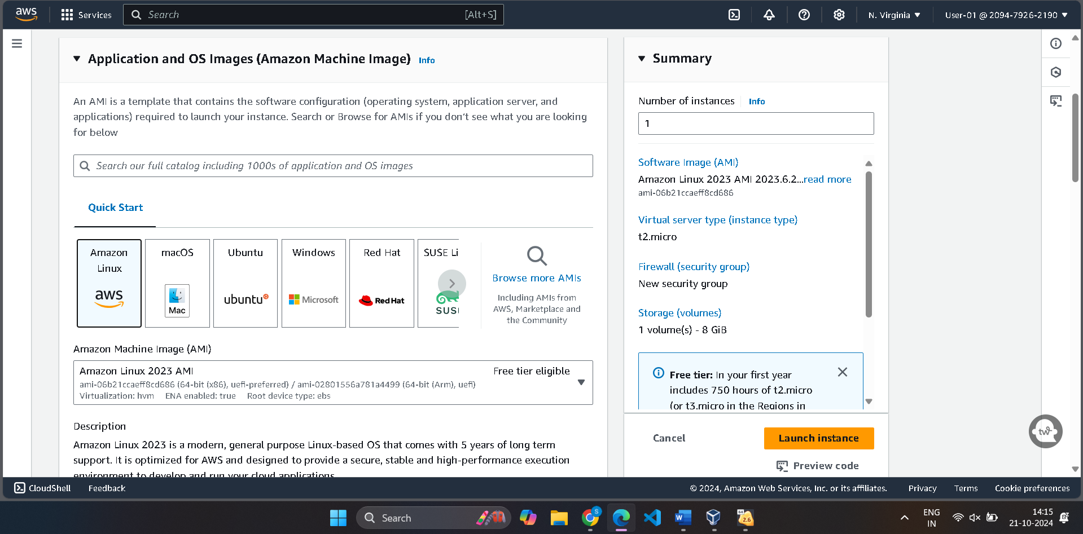

Select Instance type as t2.micro which is eligible for free tier

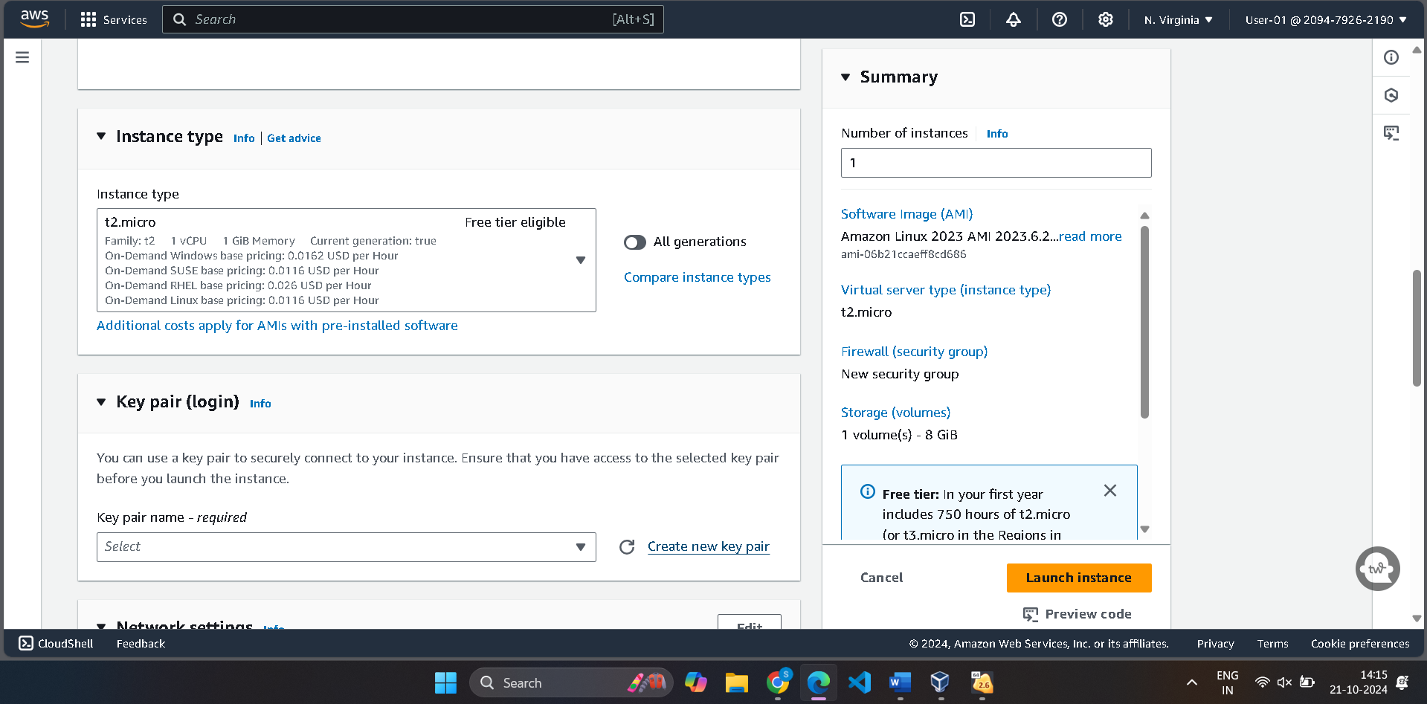

Step 7. Generate the new key pair in .ppk format to run on putty.

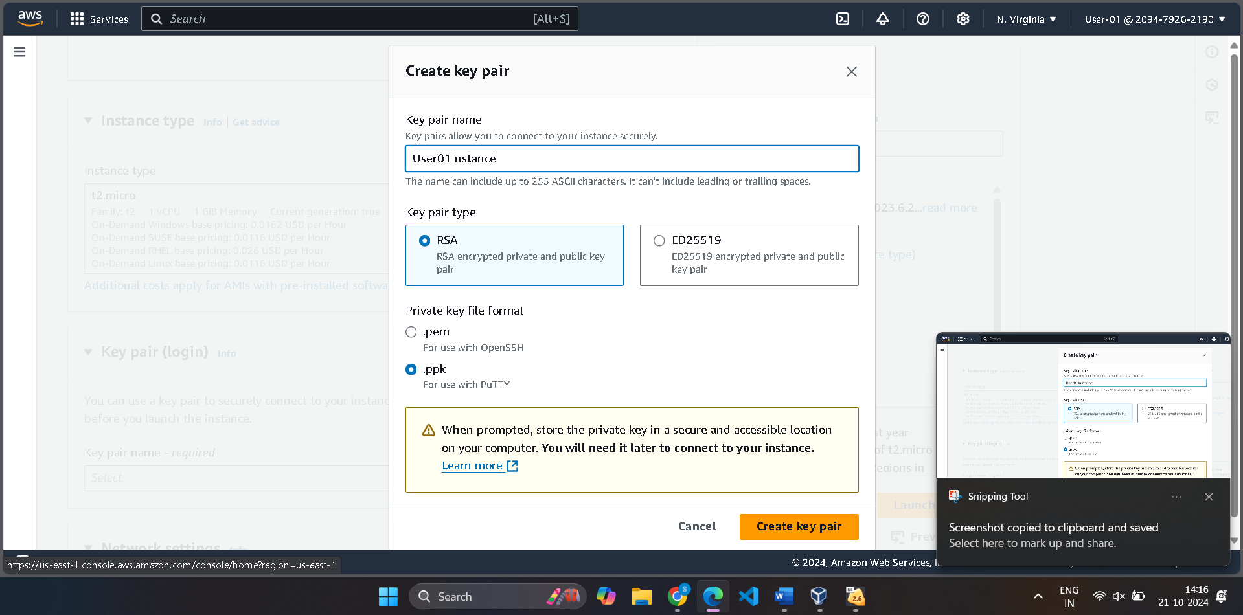

Step 8. In network settings, Allow traffic from HTTP and HTTPs as well. And Click on Launch Instance

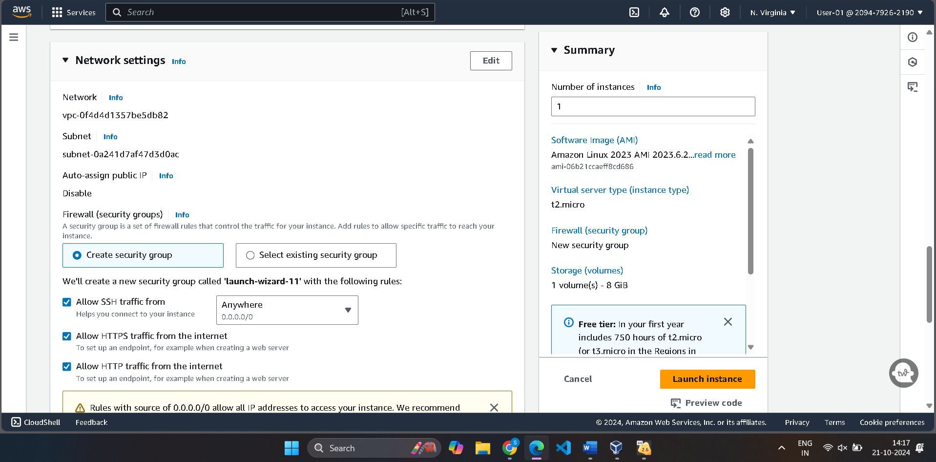

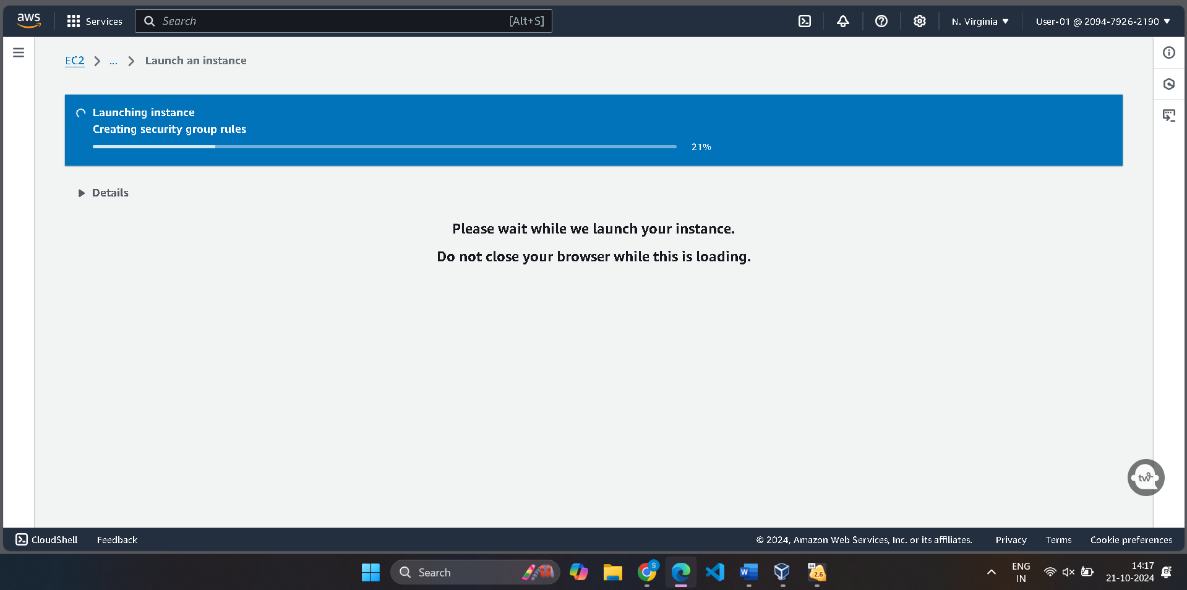

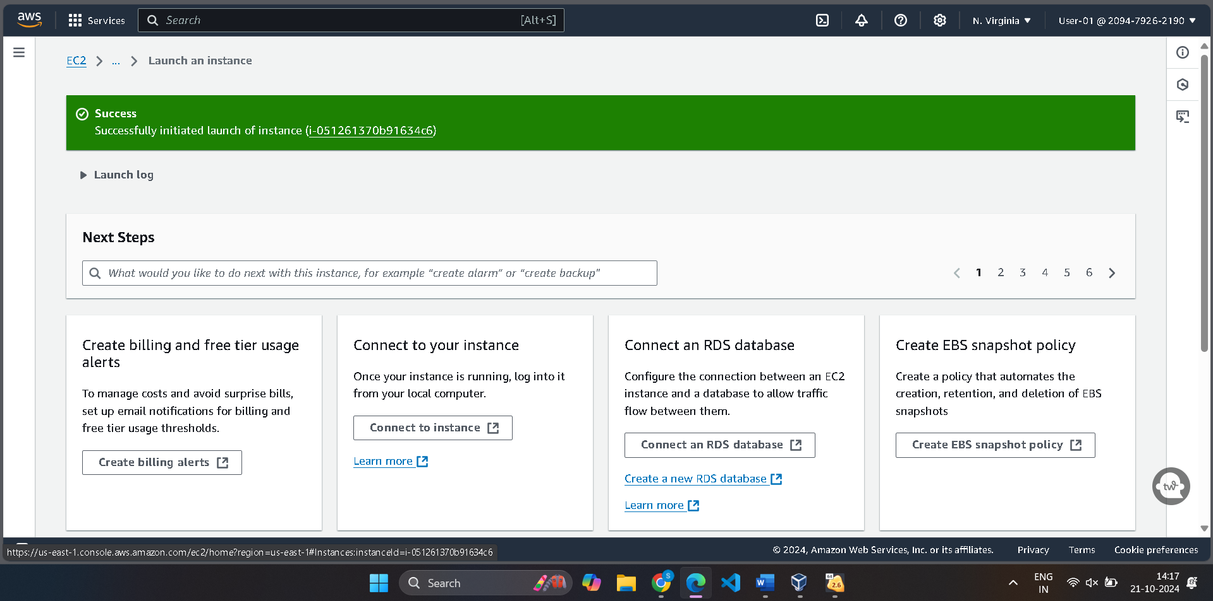

Your Instance is created successfully.

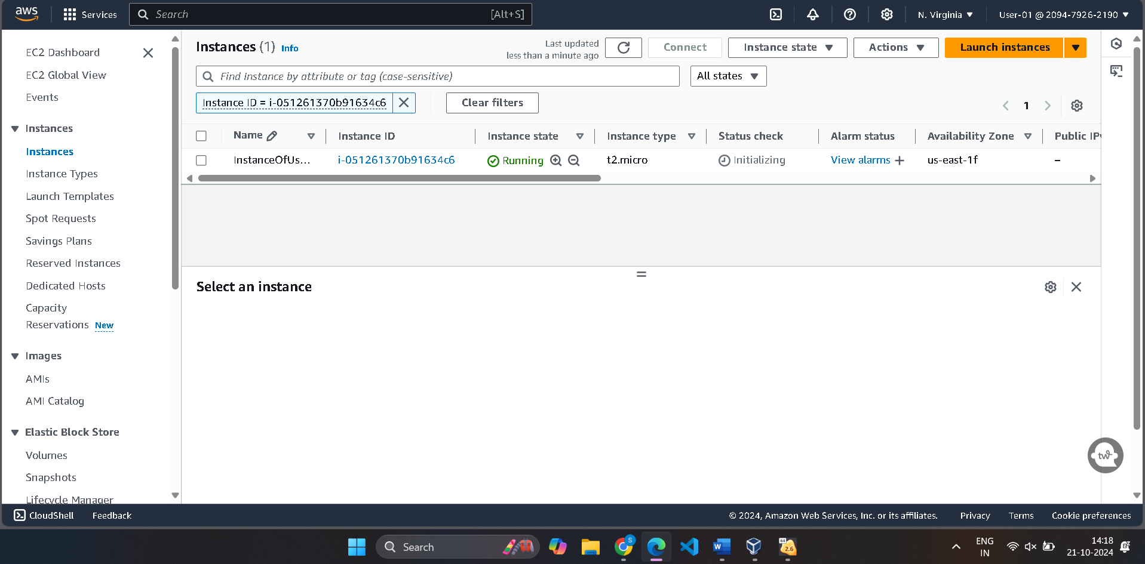

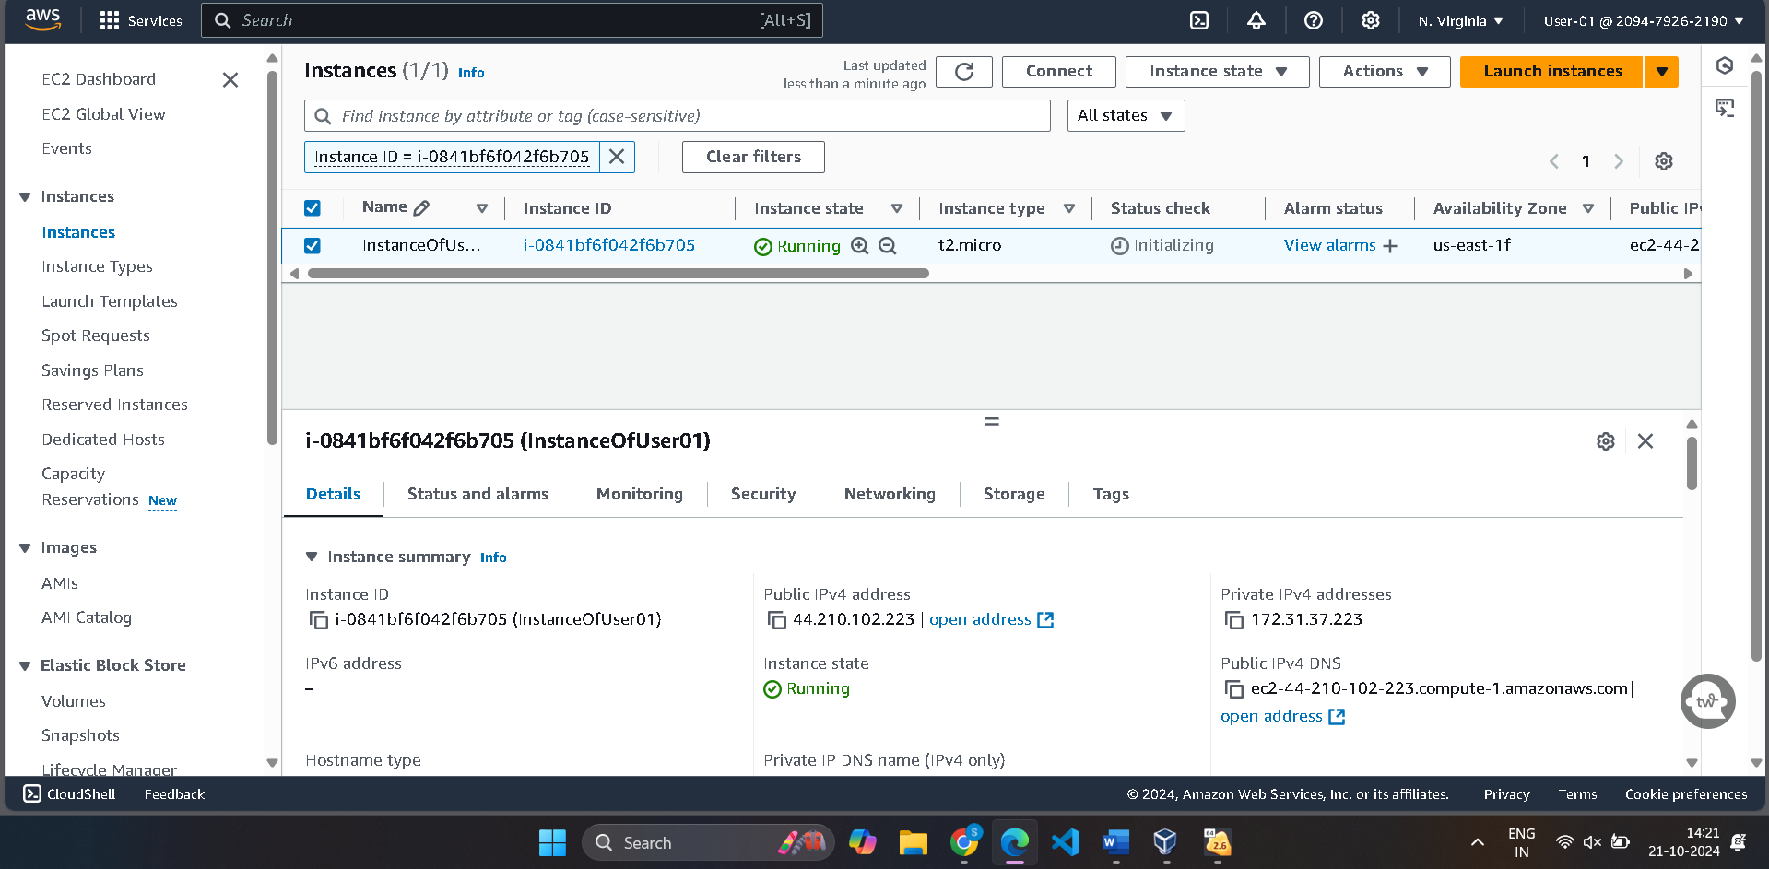

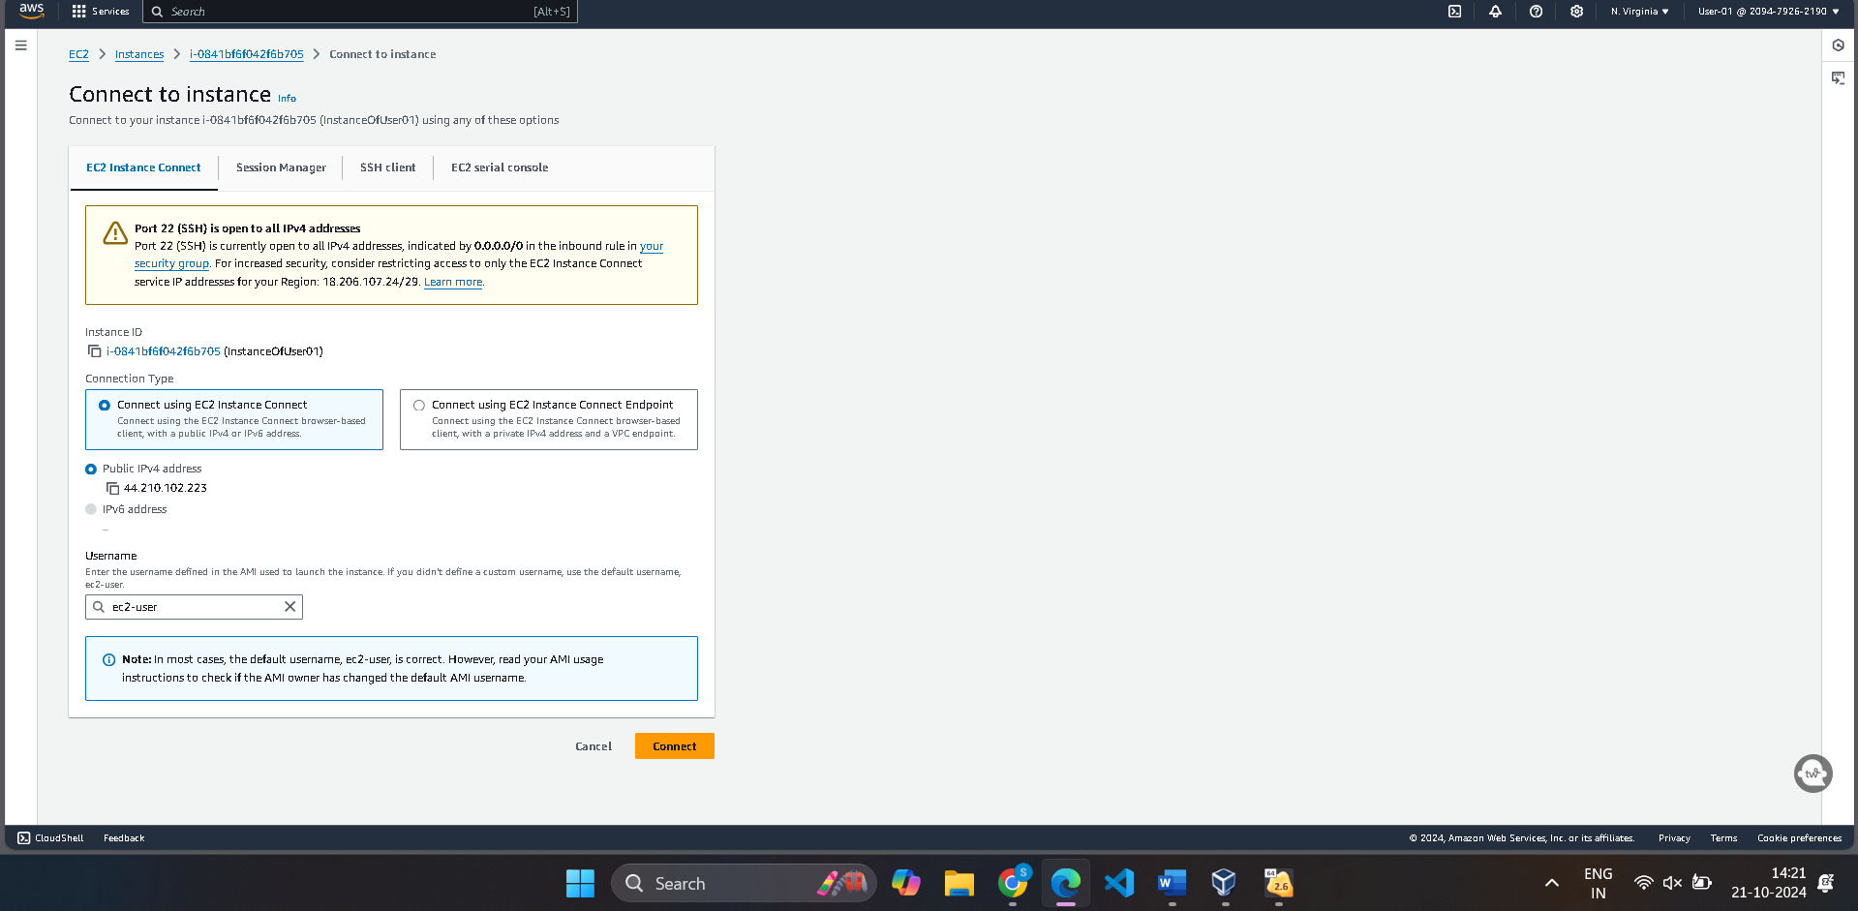

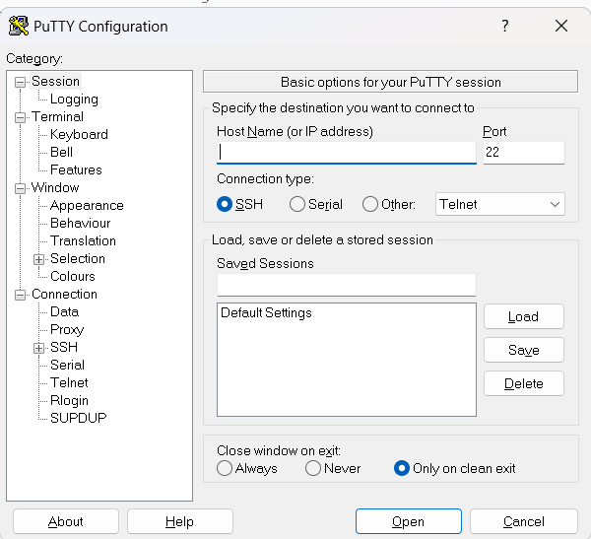

Copy the Public IP Address of the instance and Paste in HostName of Putty

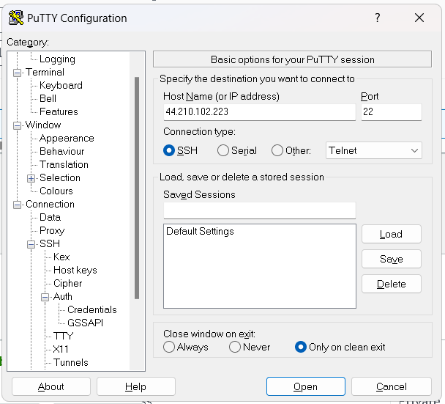

Click on Connections then SSH And then Auth

Click on Credentials and browse the key(.ppk) file and click on open

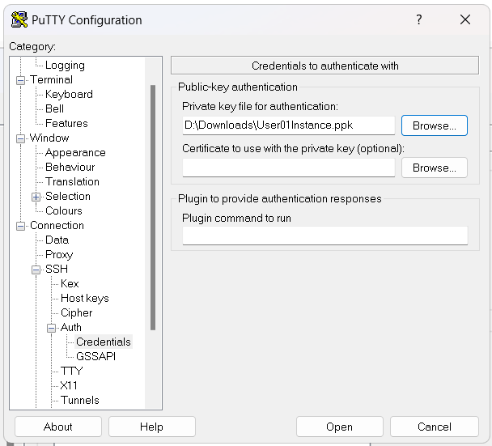

You will be redirected to terminal

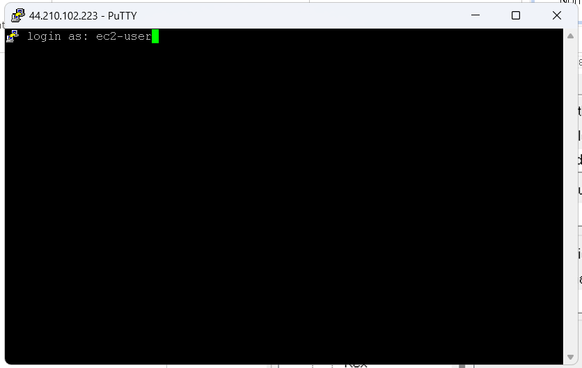

Follow the commands as below:

1. Sudo -i
2. Yum update -y
3. Yum install httpd -y
4. Systemctl start httpd
5. Systemctl enable httpd
6. Cd /var/www/html
7. Nano index.html

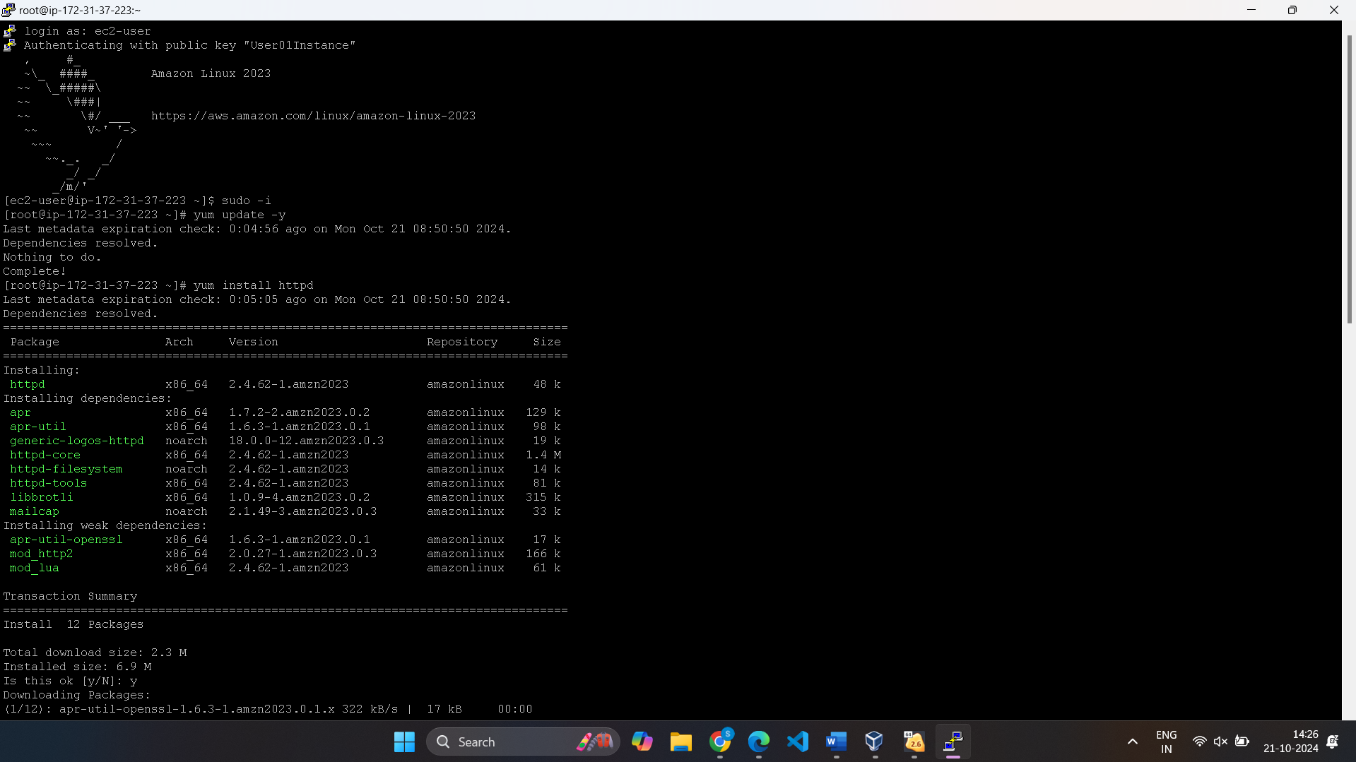

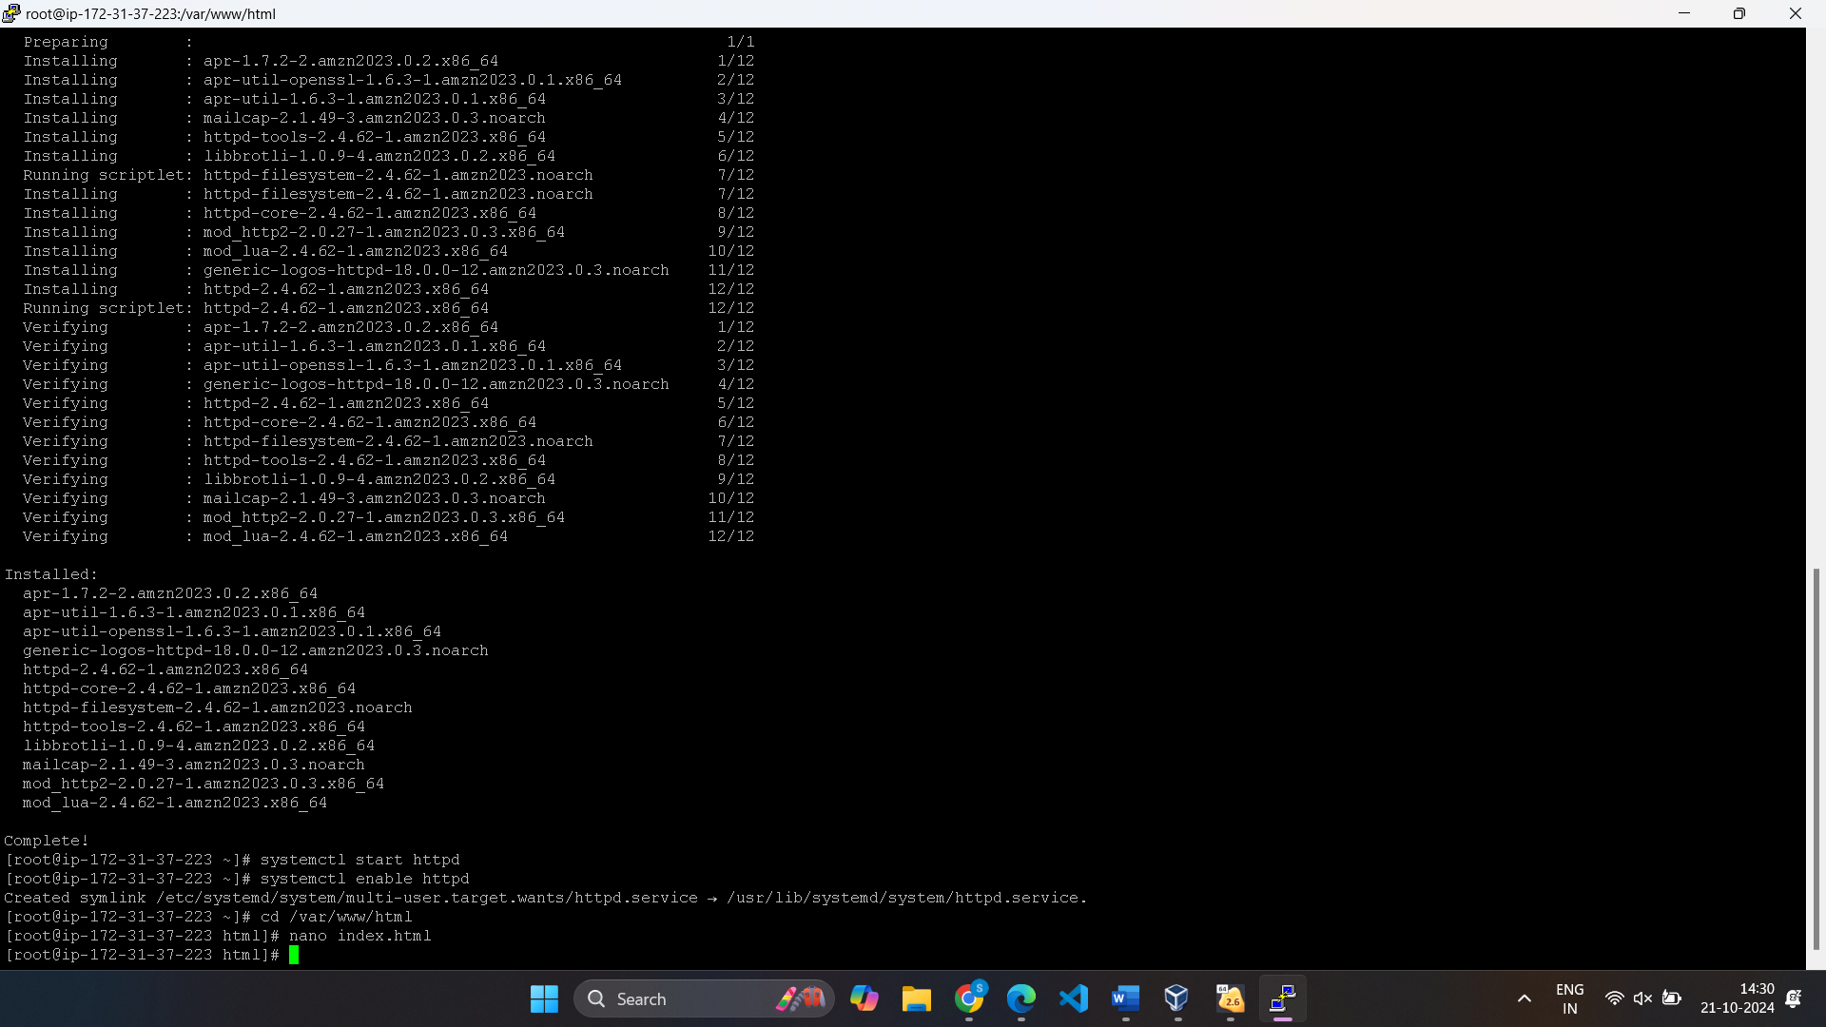

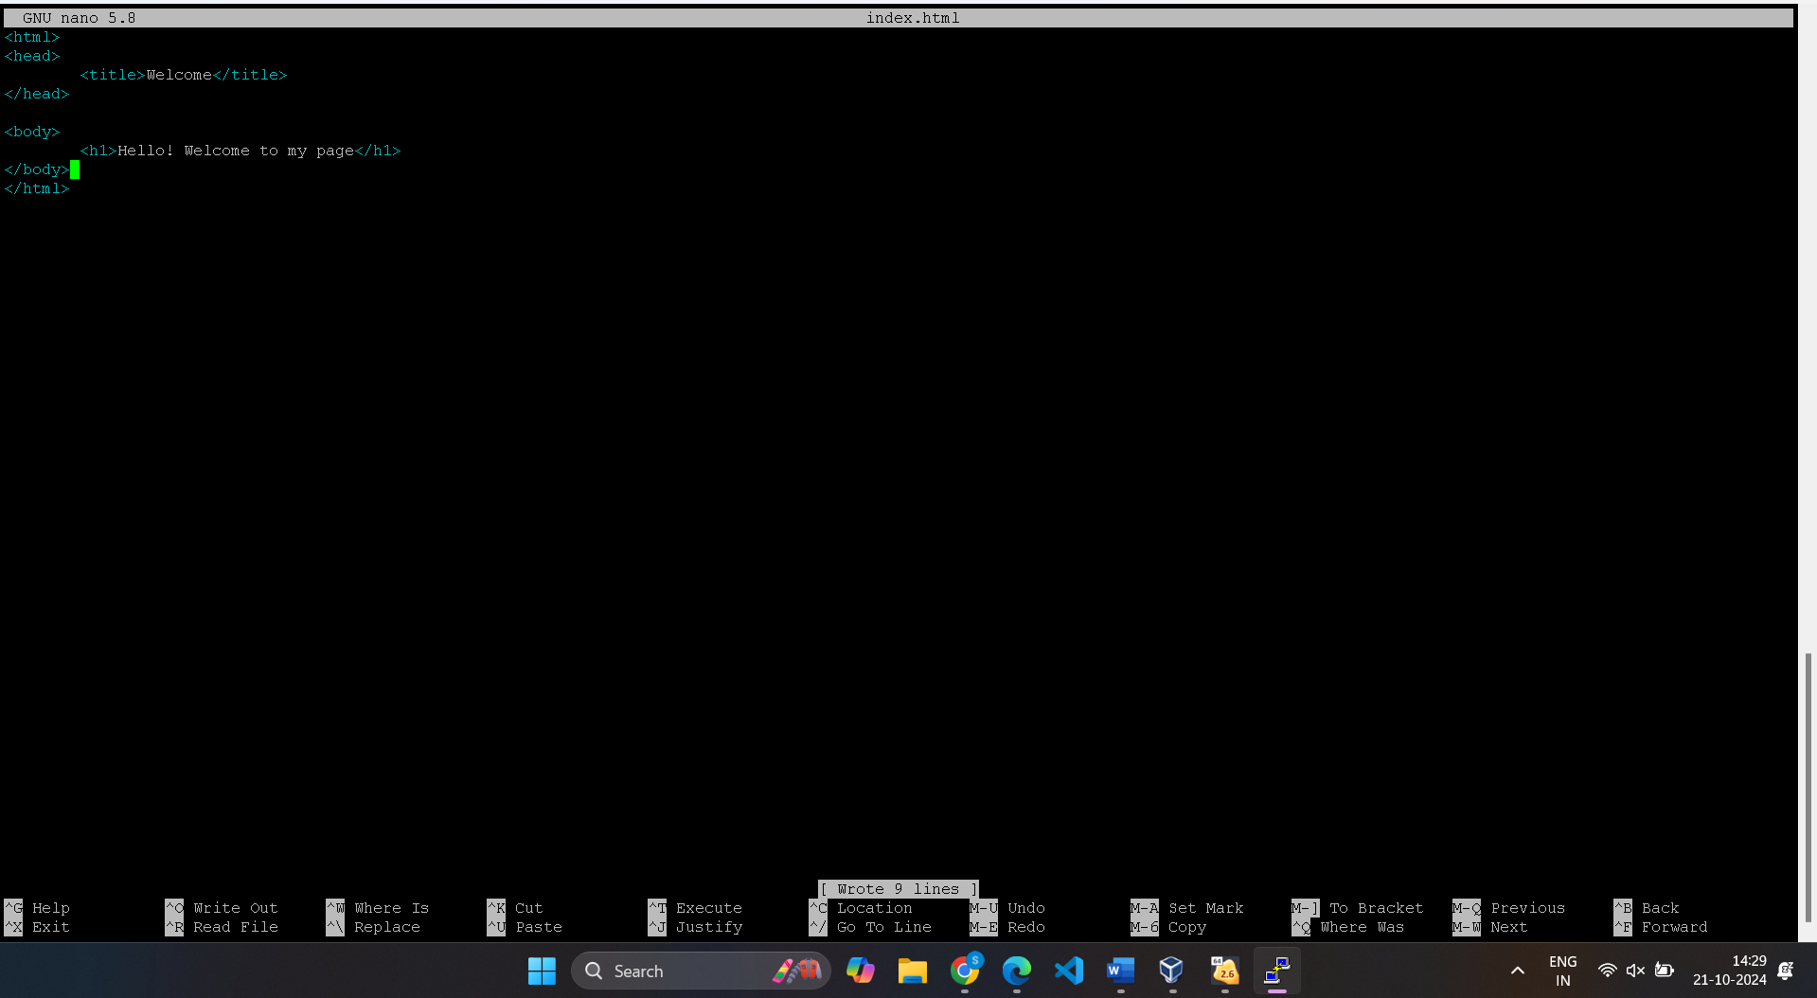

Write your html code in nano editor.

And save it

In aws instance page, You can open the link or copy ip and run your page

[Welcome](http://3.229.134.133/)

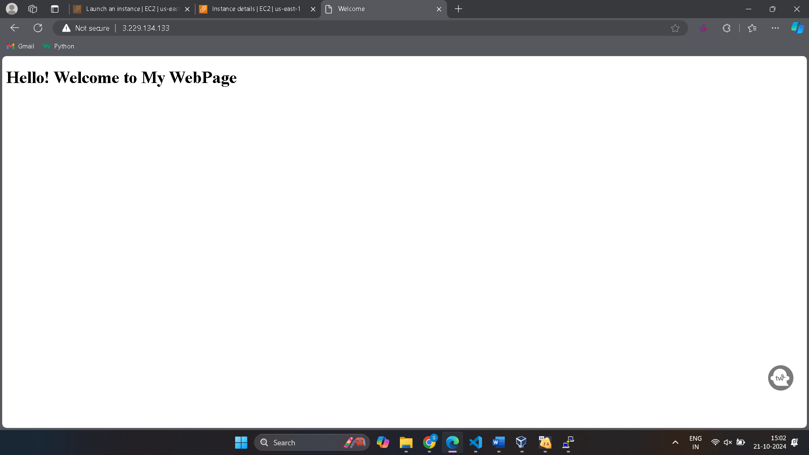

**Ques 3**. Additionally create s3

On Aws Home Page, Search for IAM user created. Provide S3FullAccess to create bucket

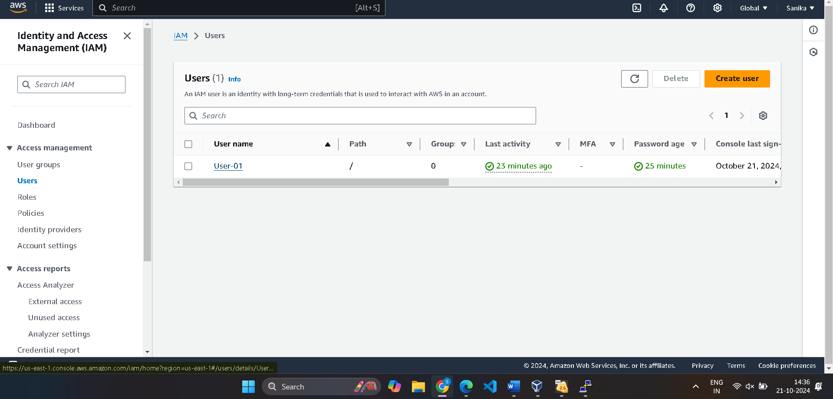

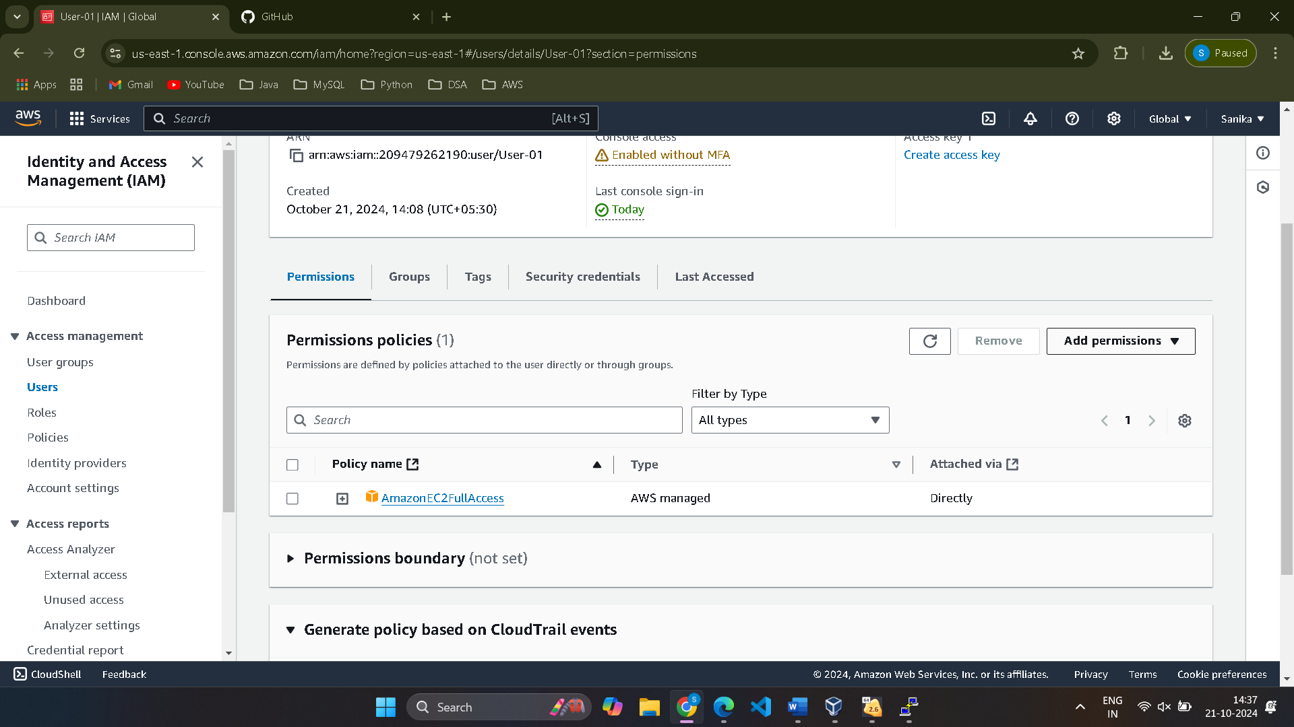

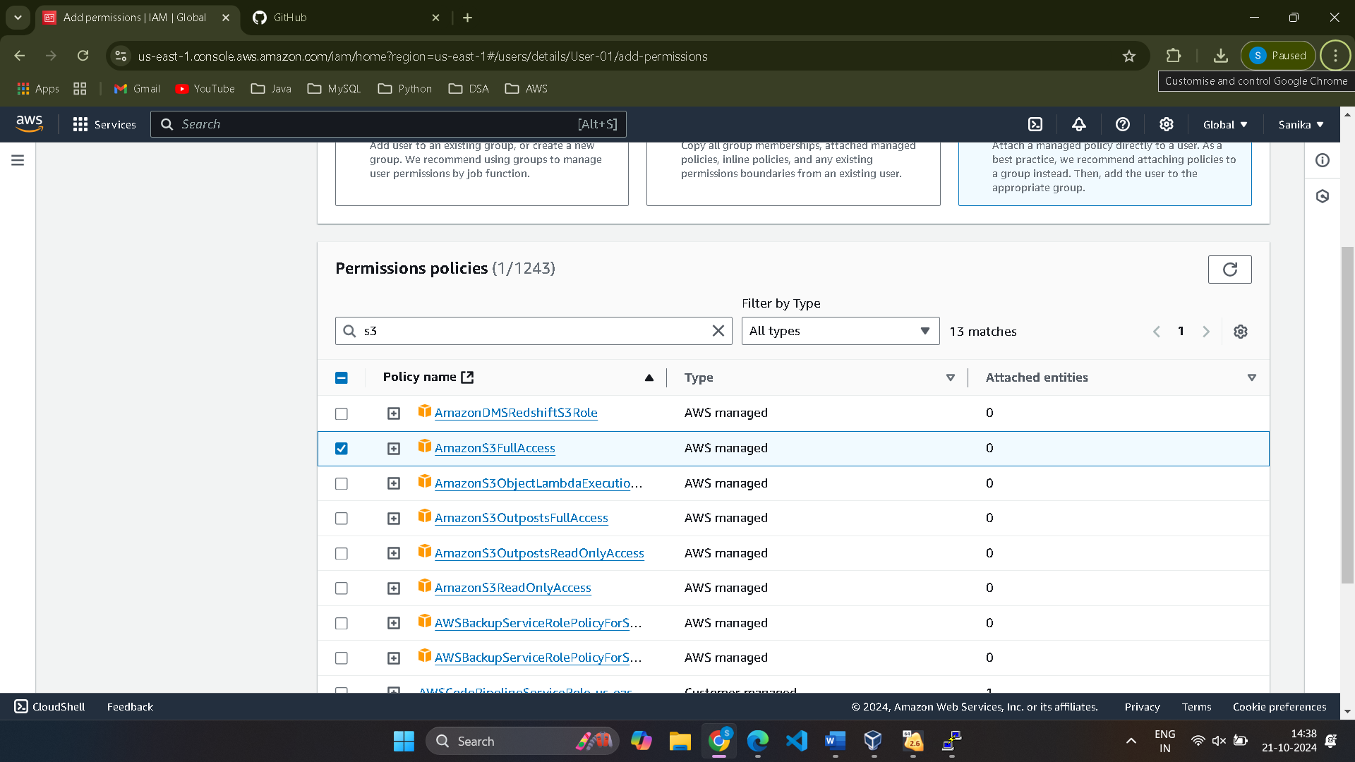

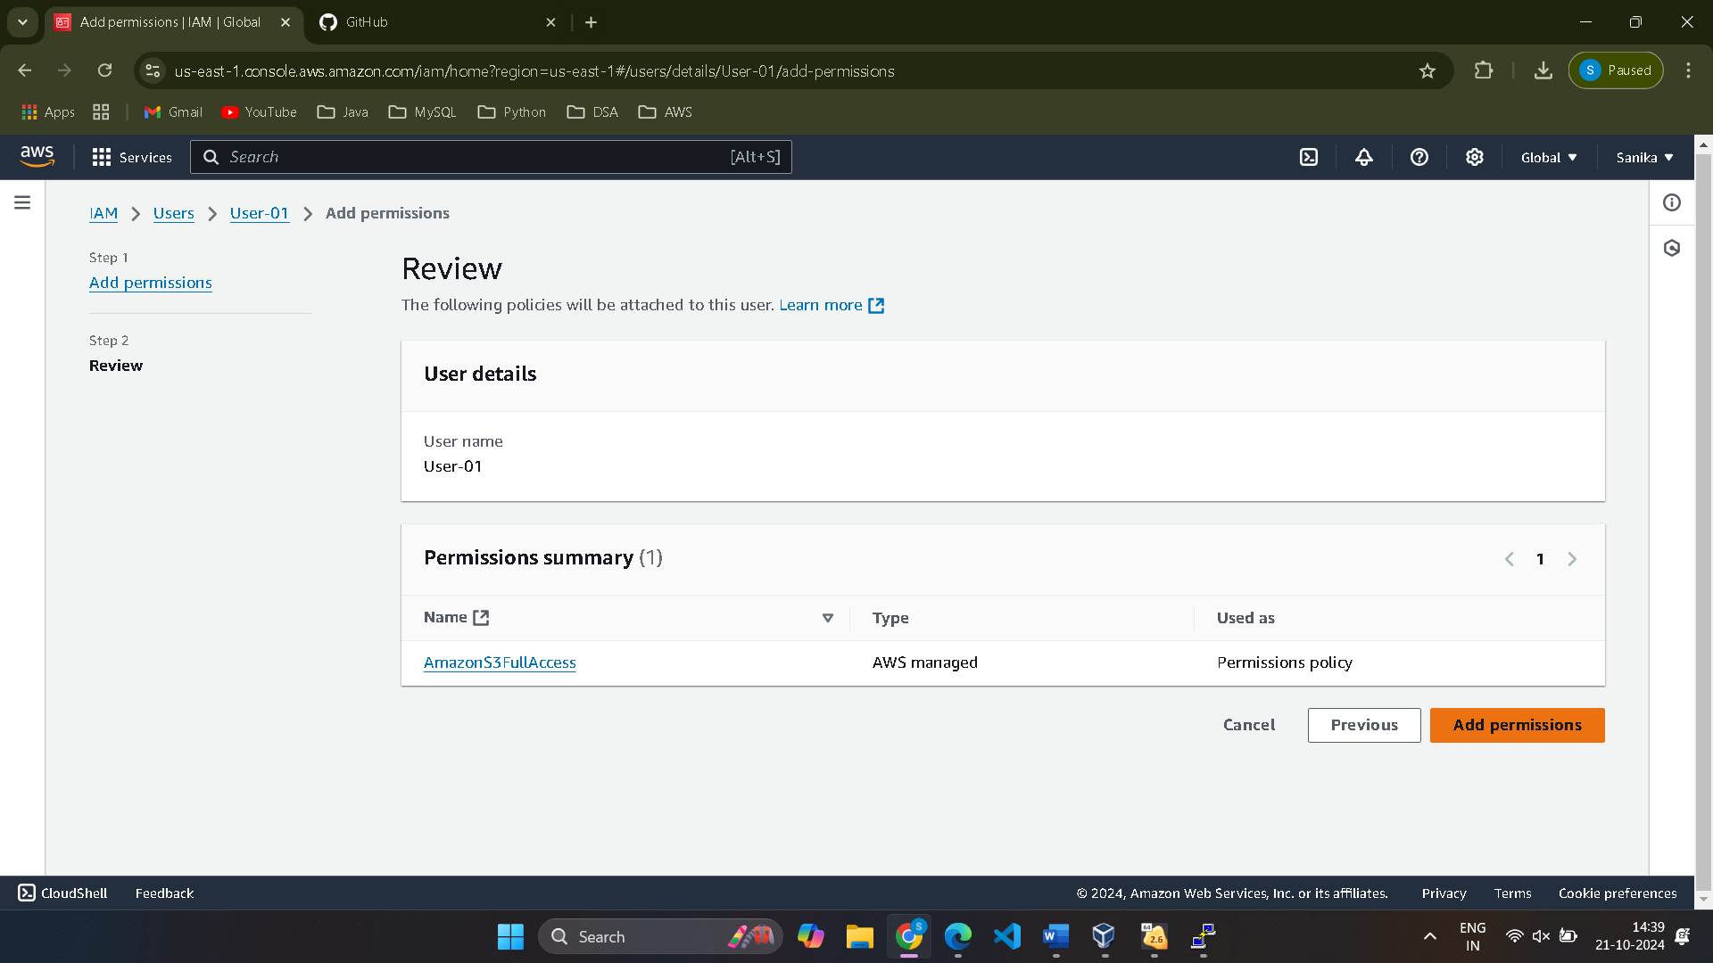

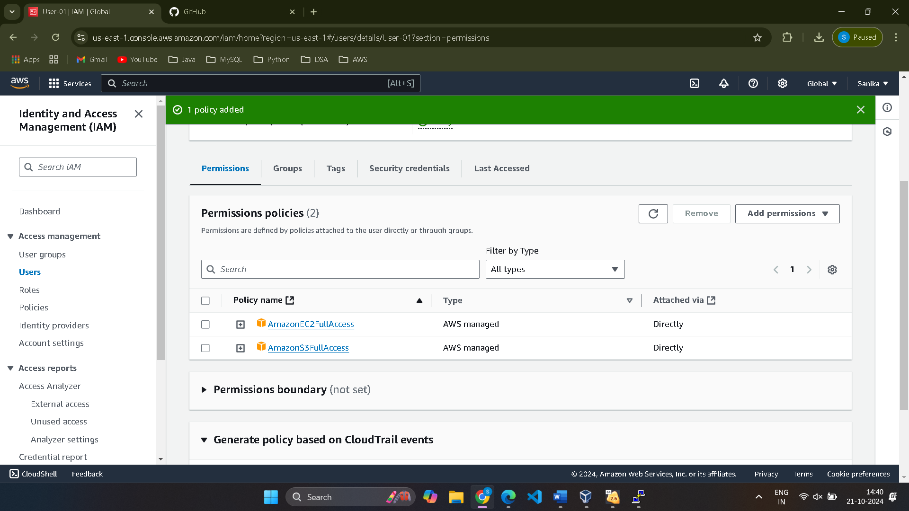

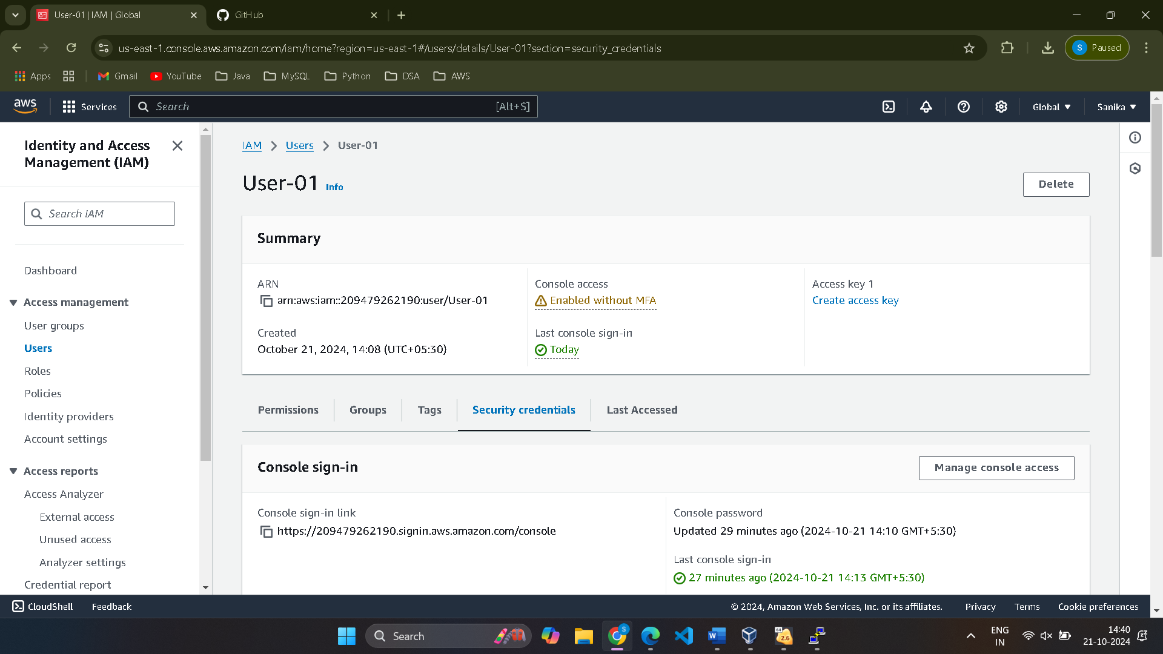

Create Access key for the user in security Credential and download the .csv file for future use.

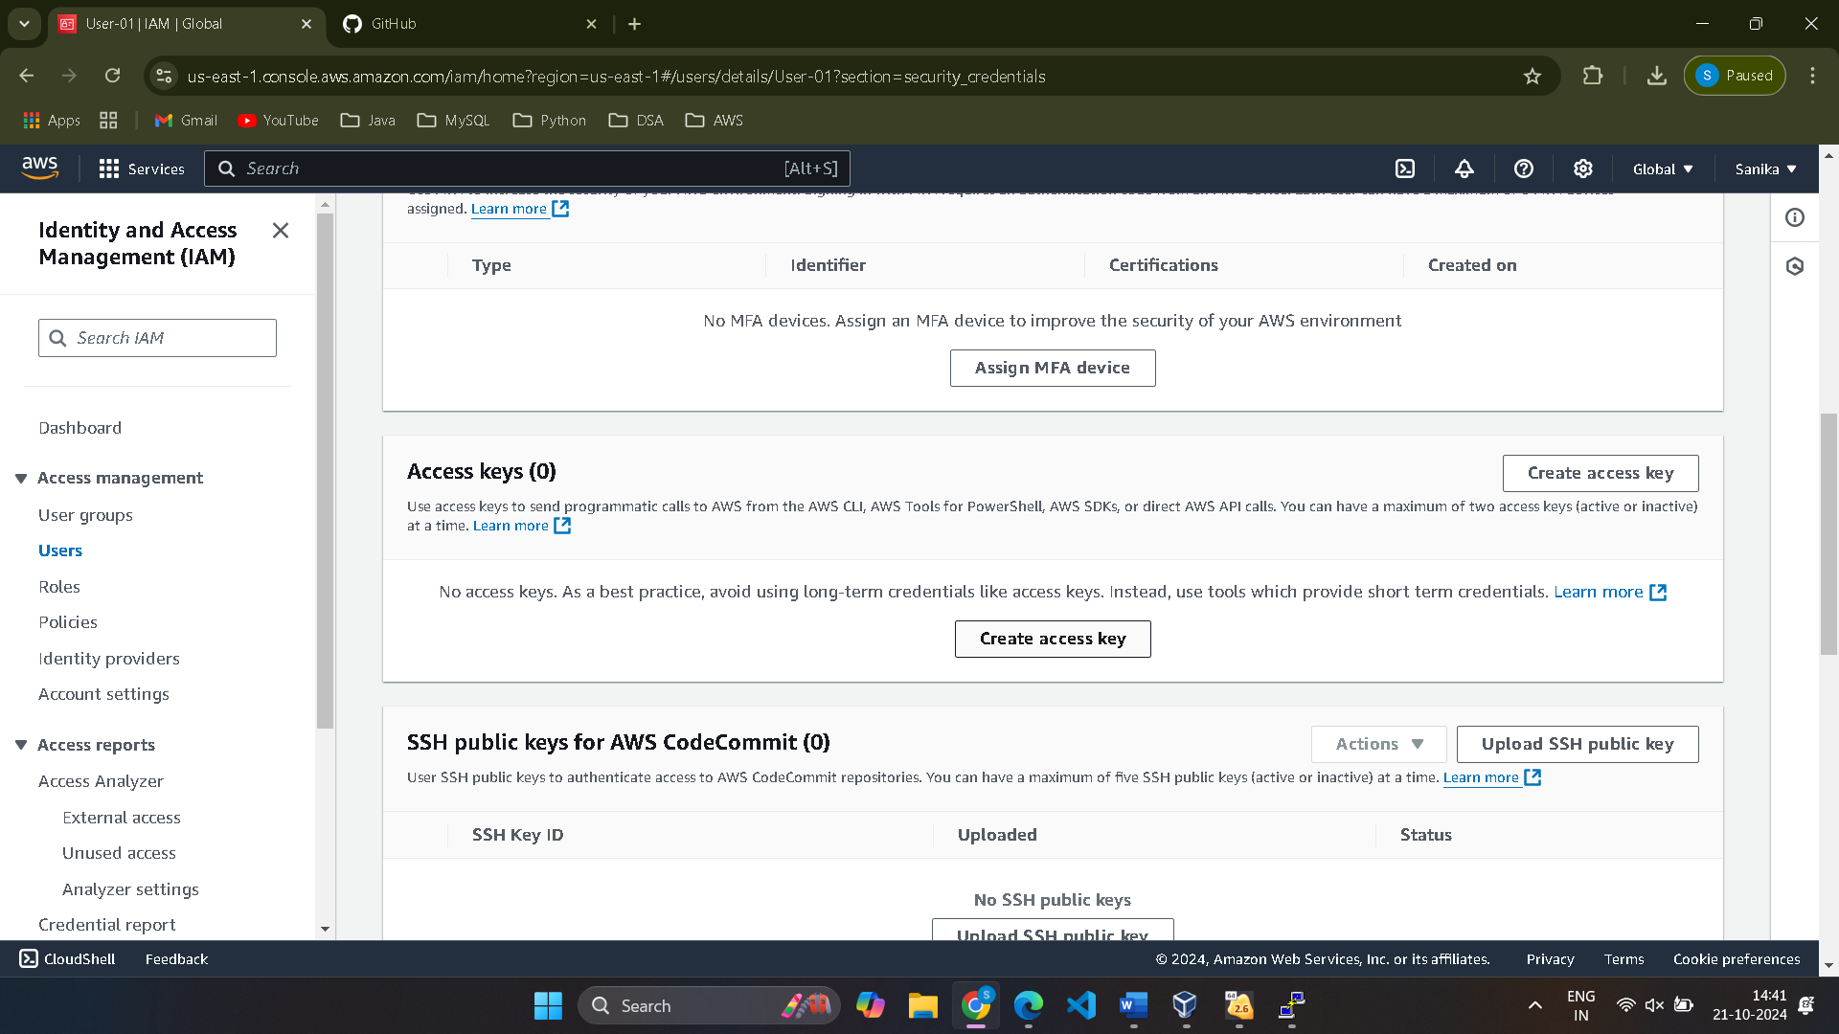

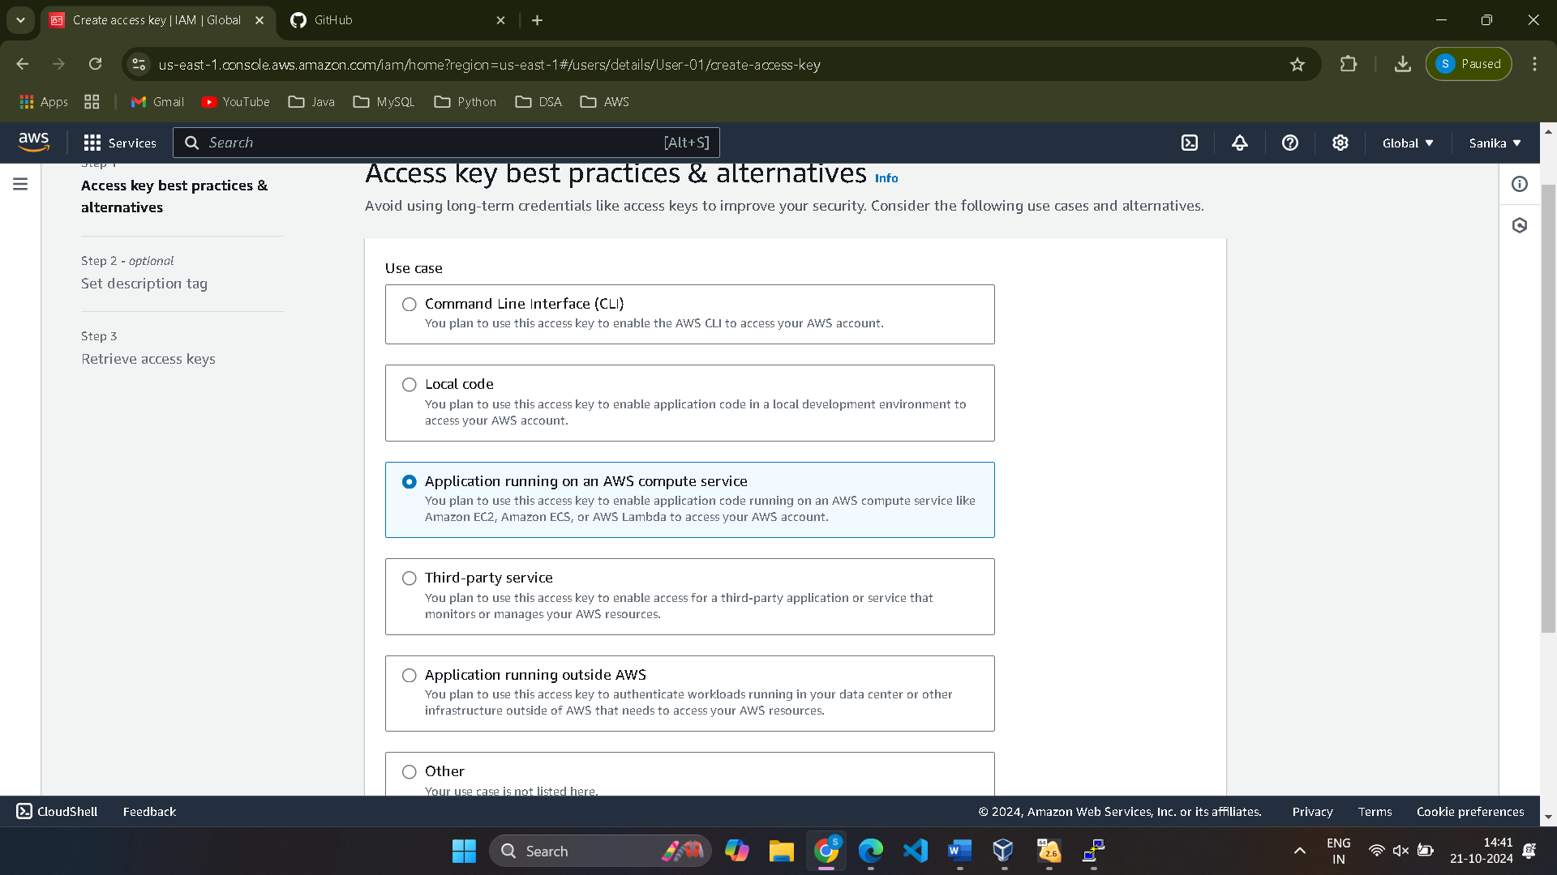

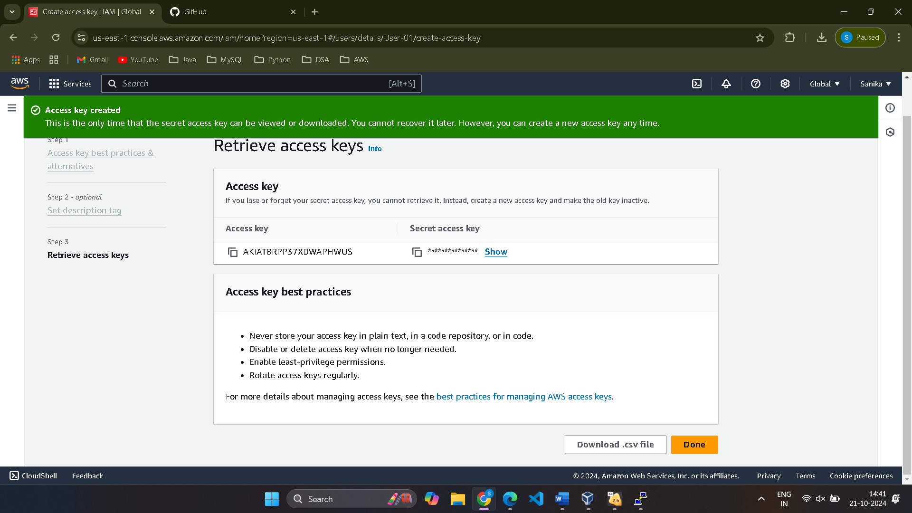

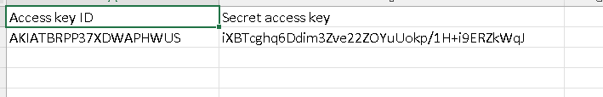

Now search S3 click on create bucket.

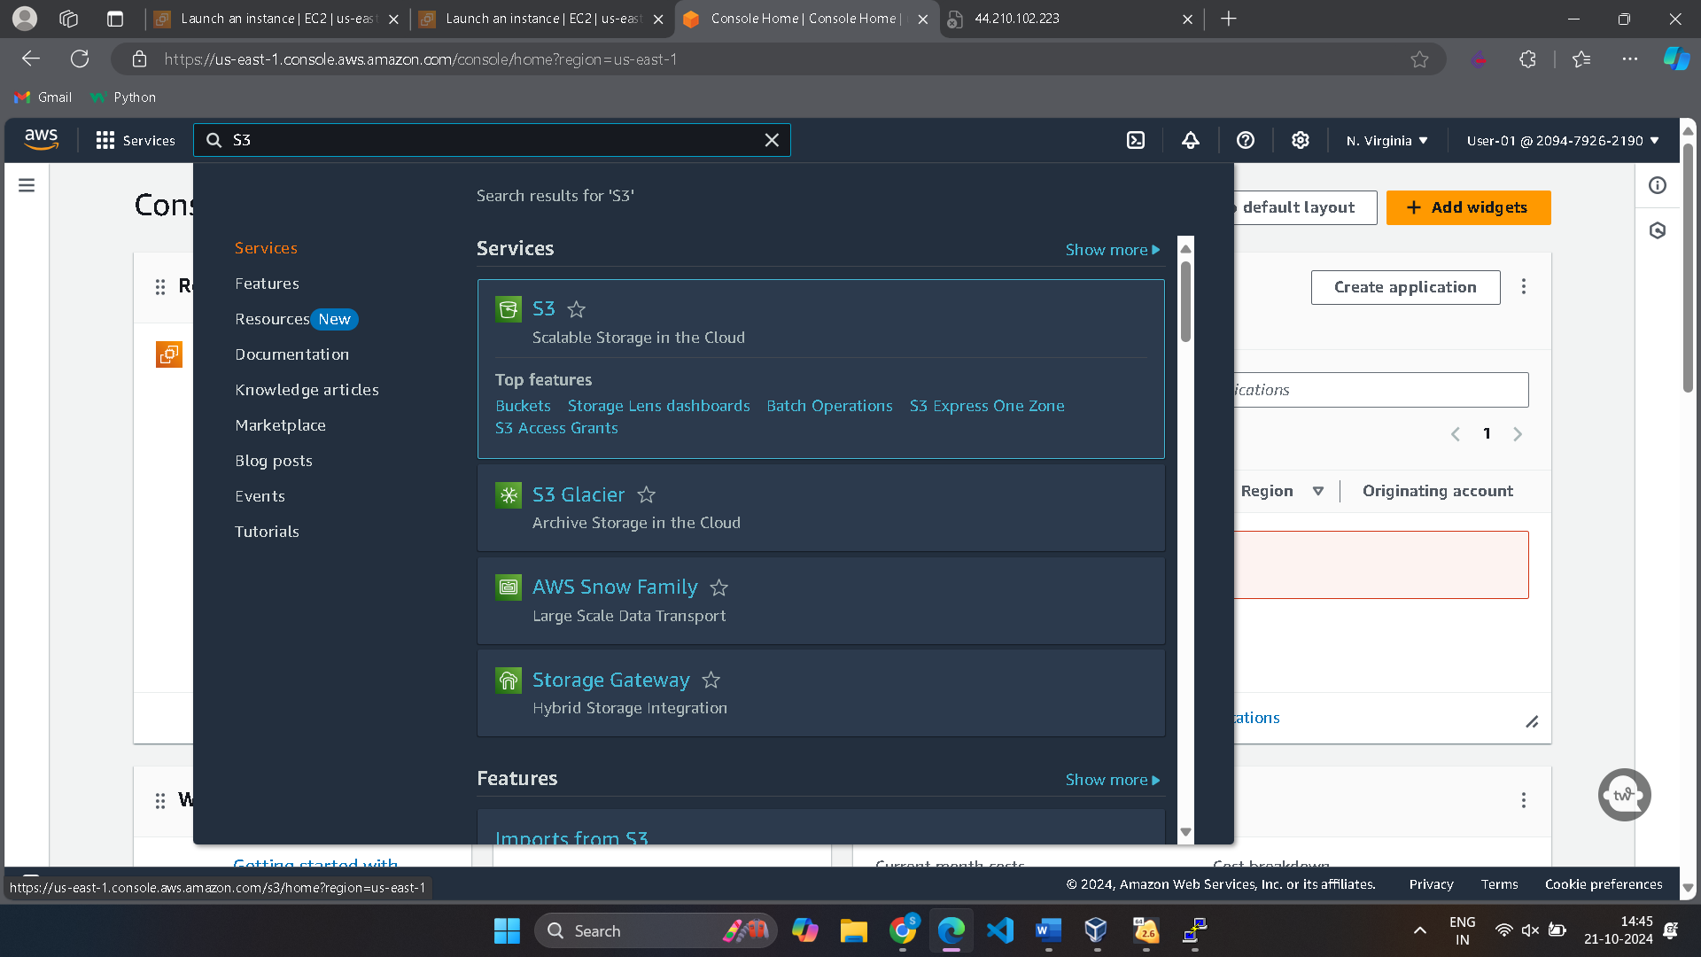

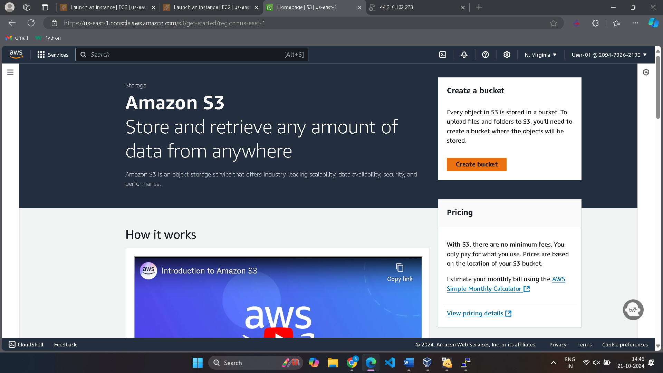

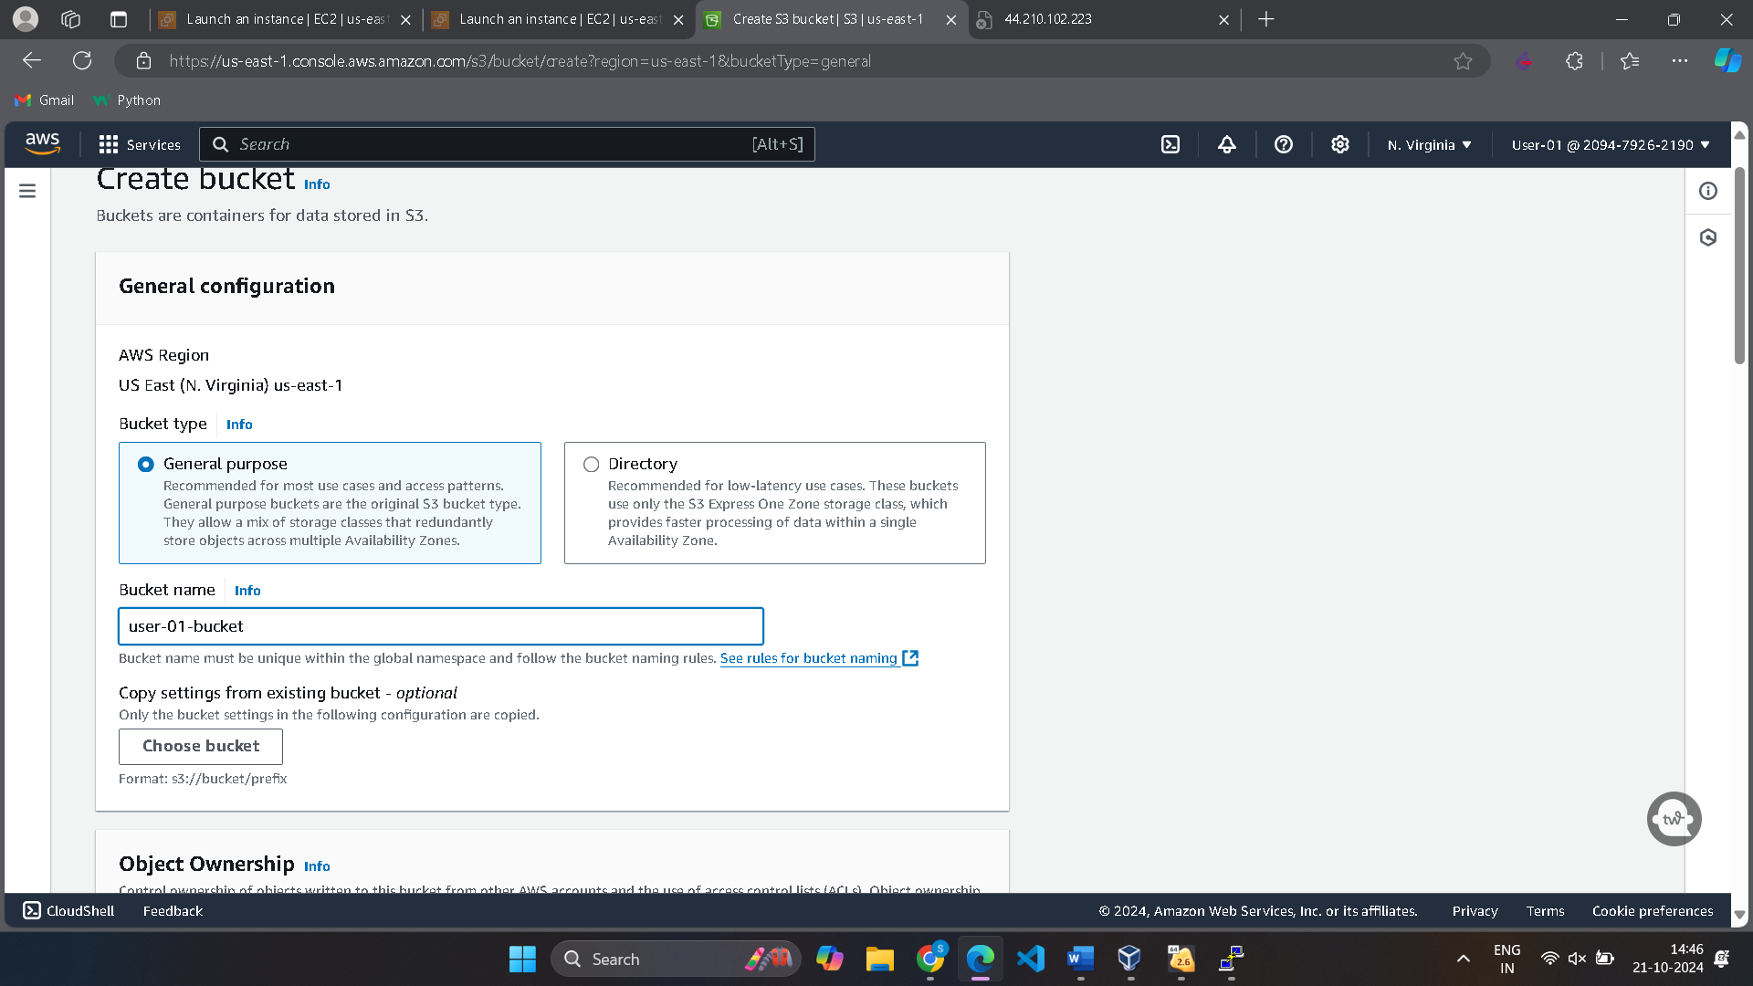

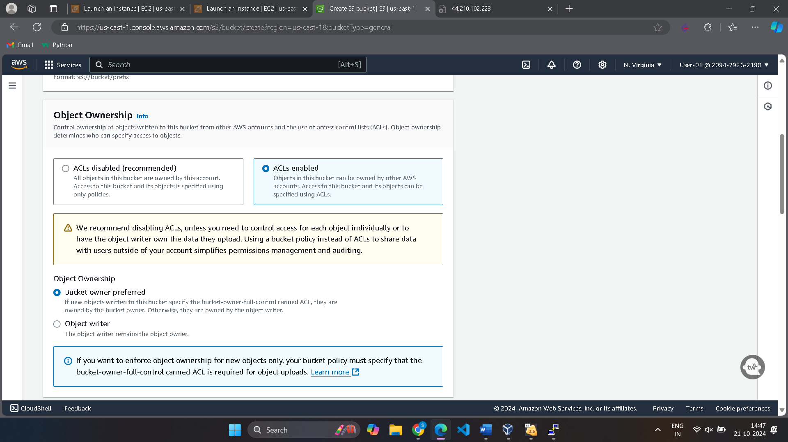

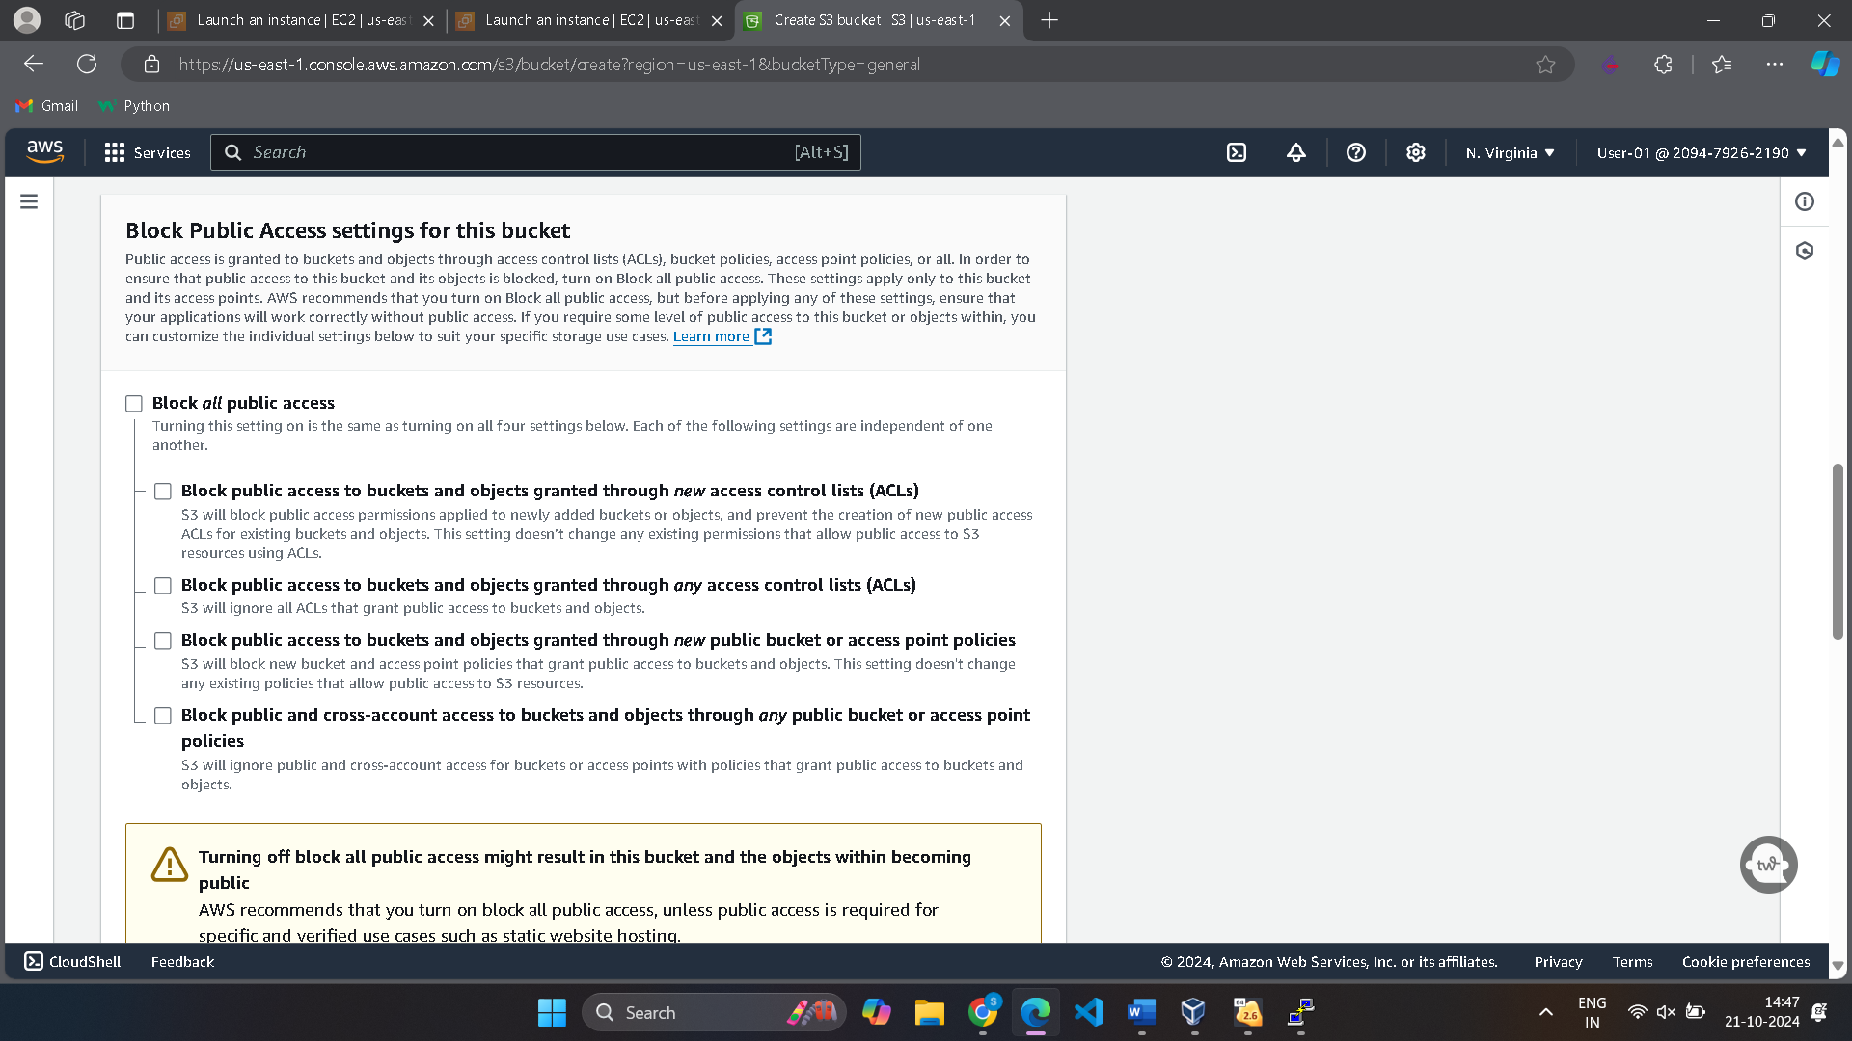

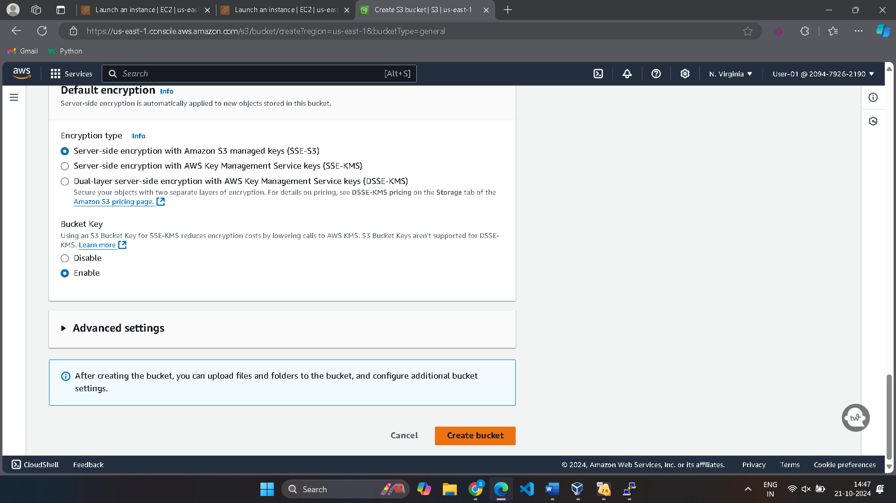

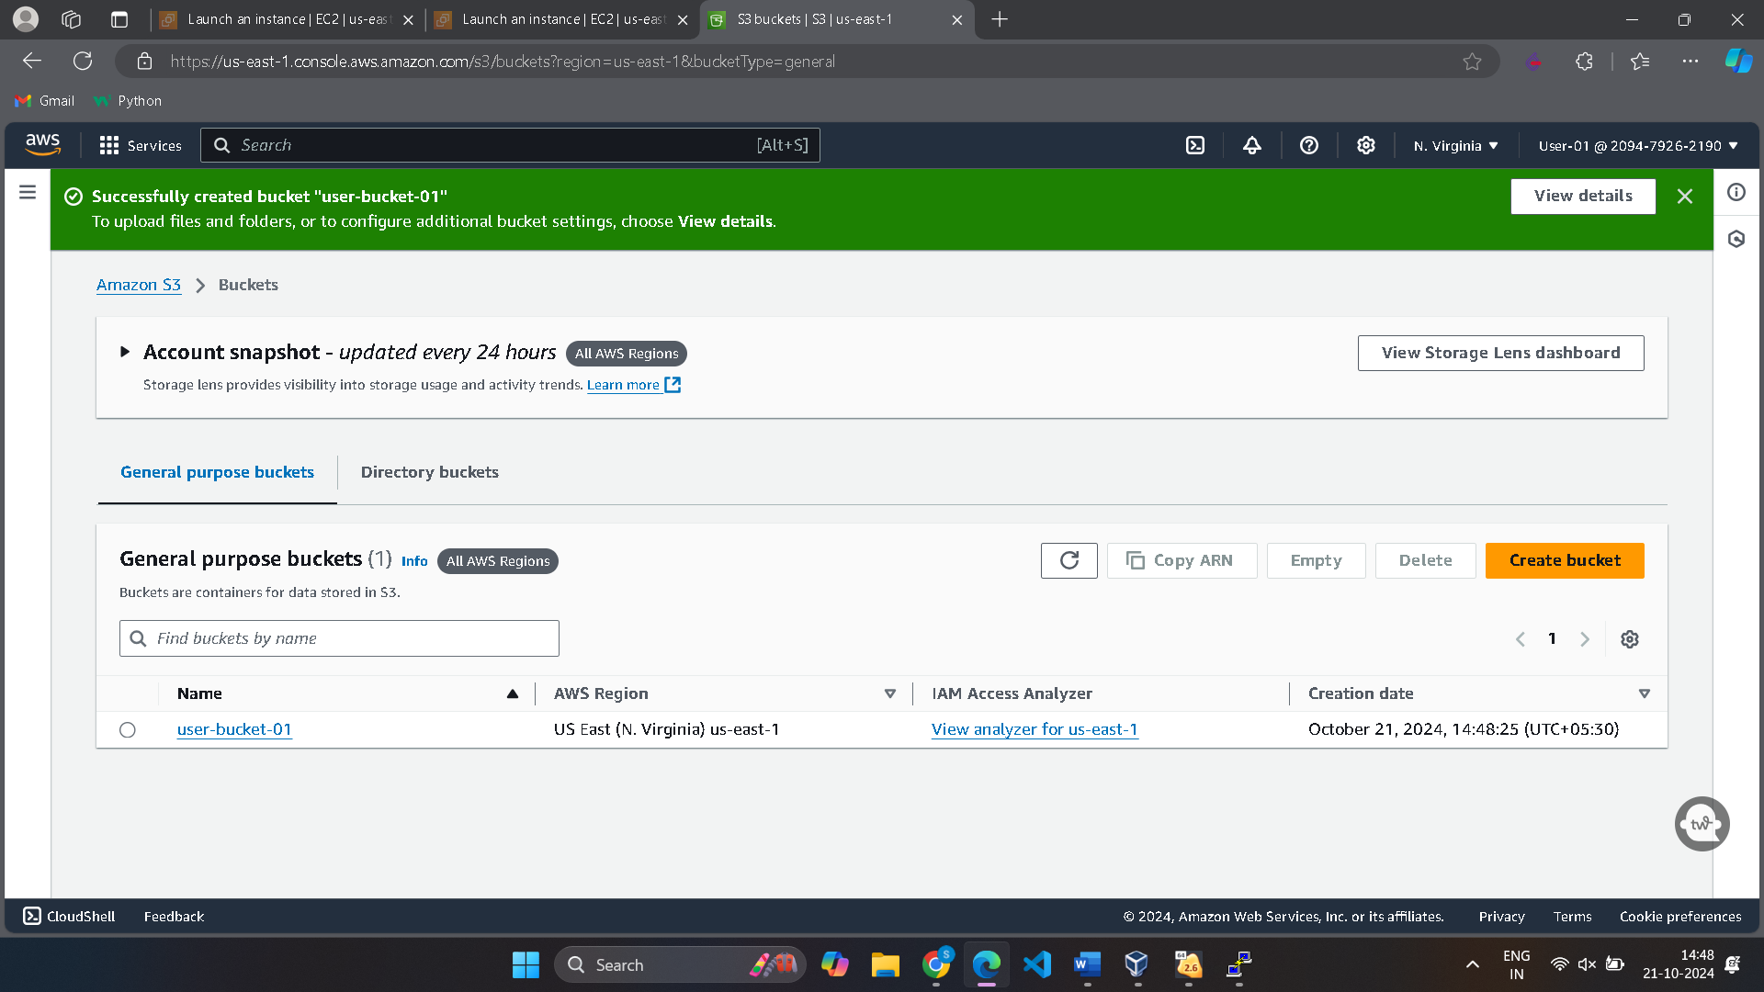

Create a html page.

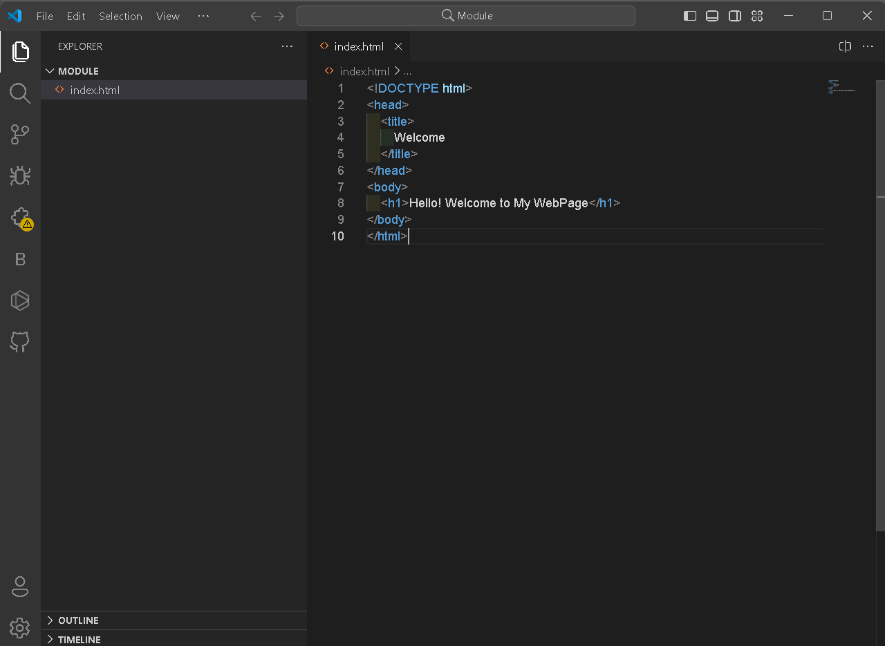

Drag the html page to your bucket. It will get uploaded

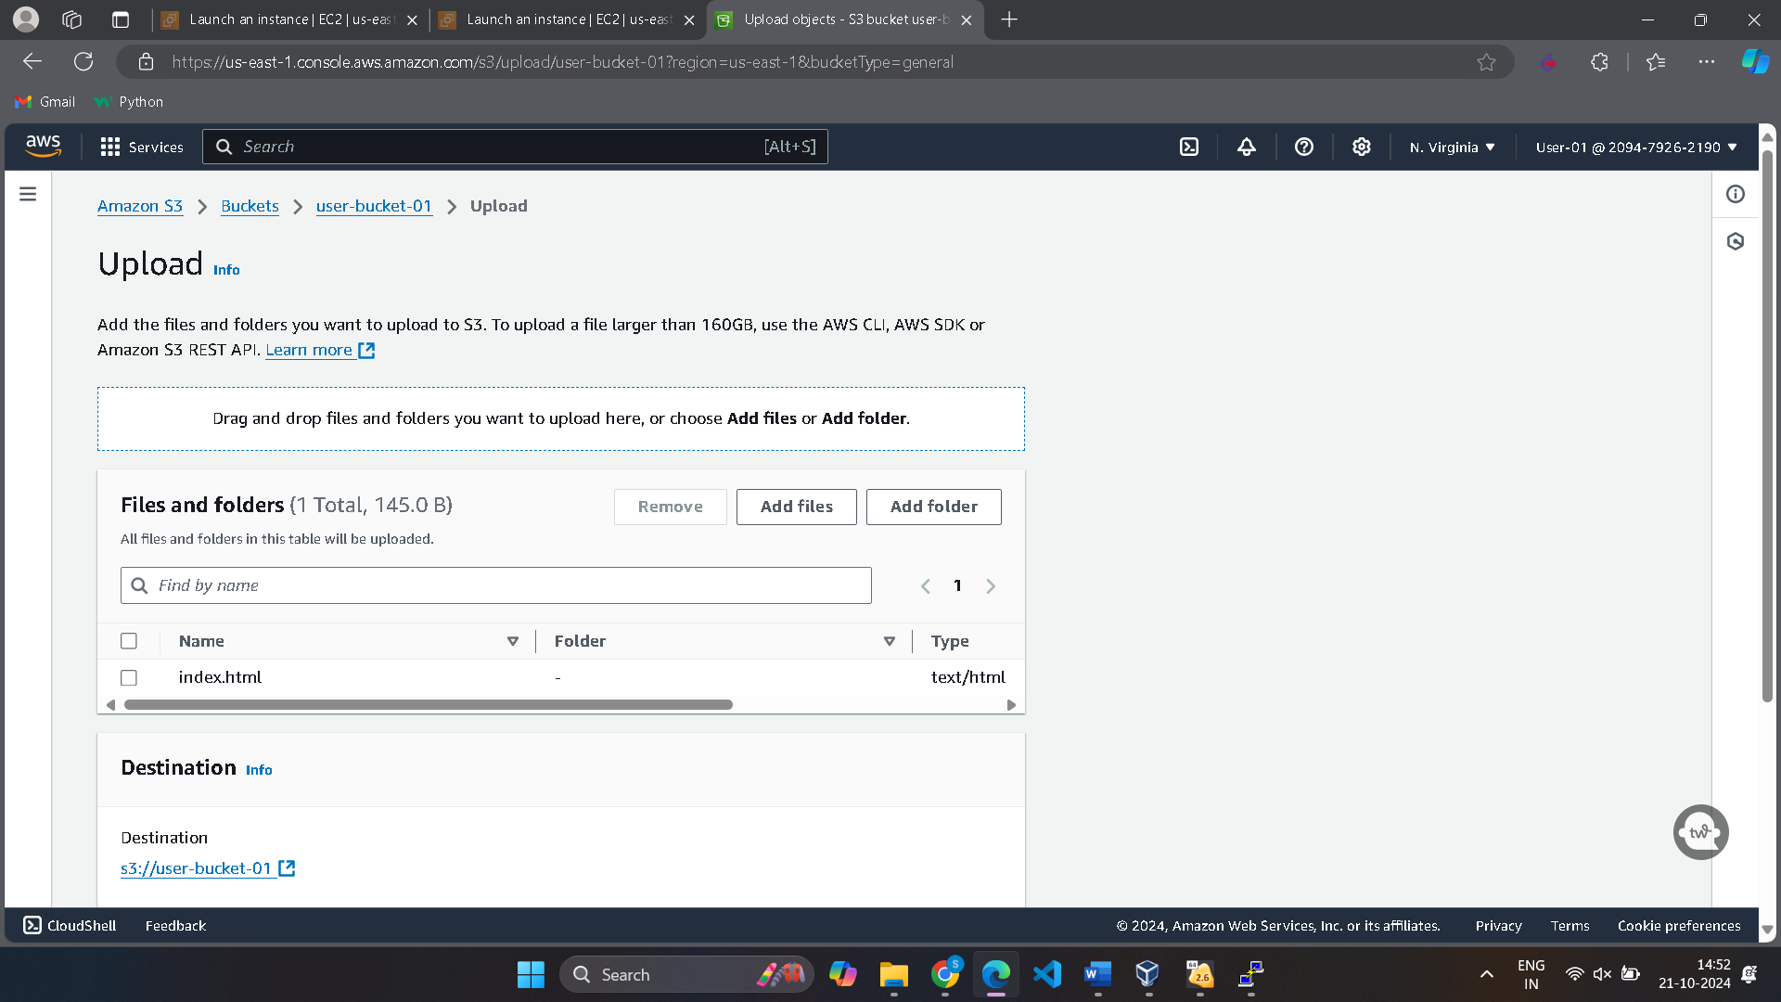

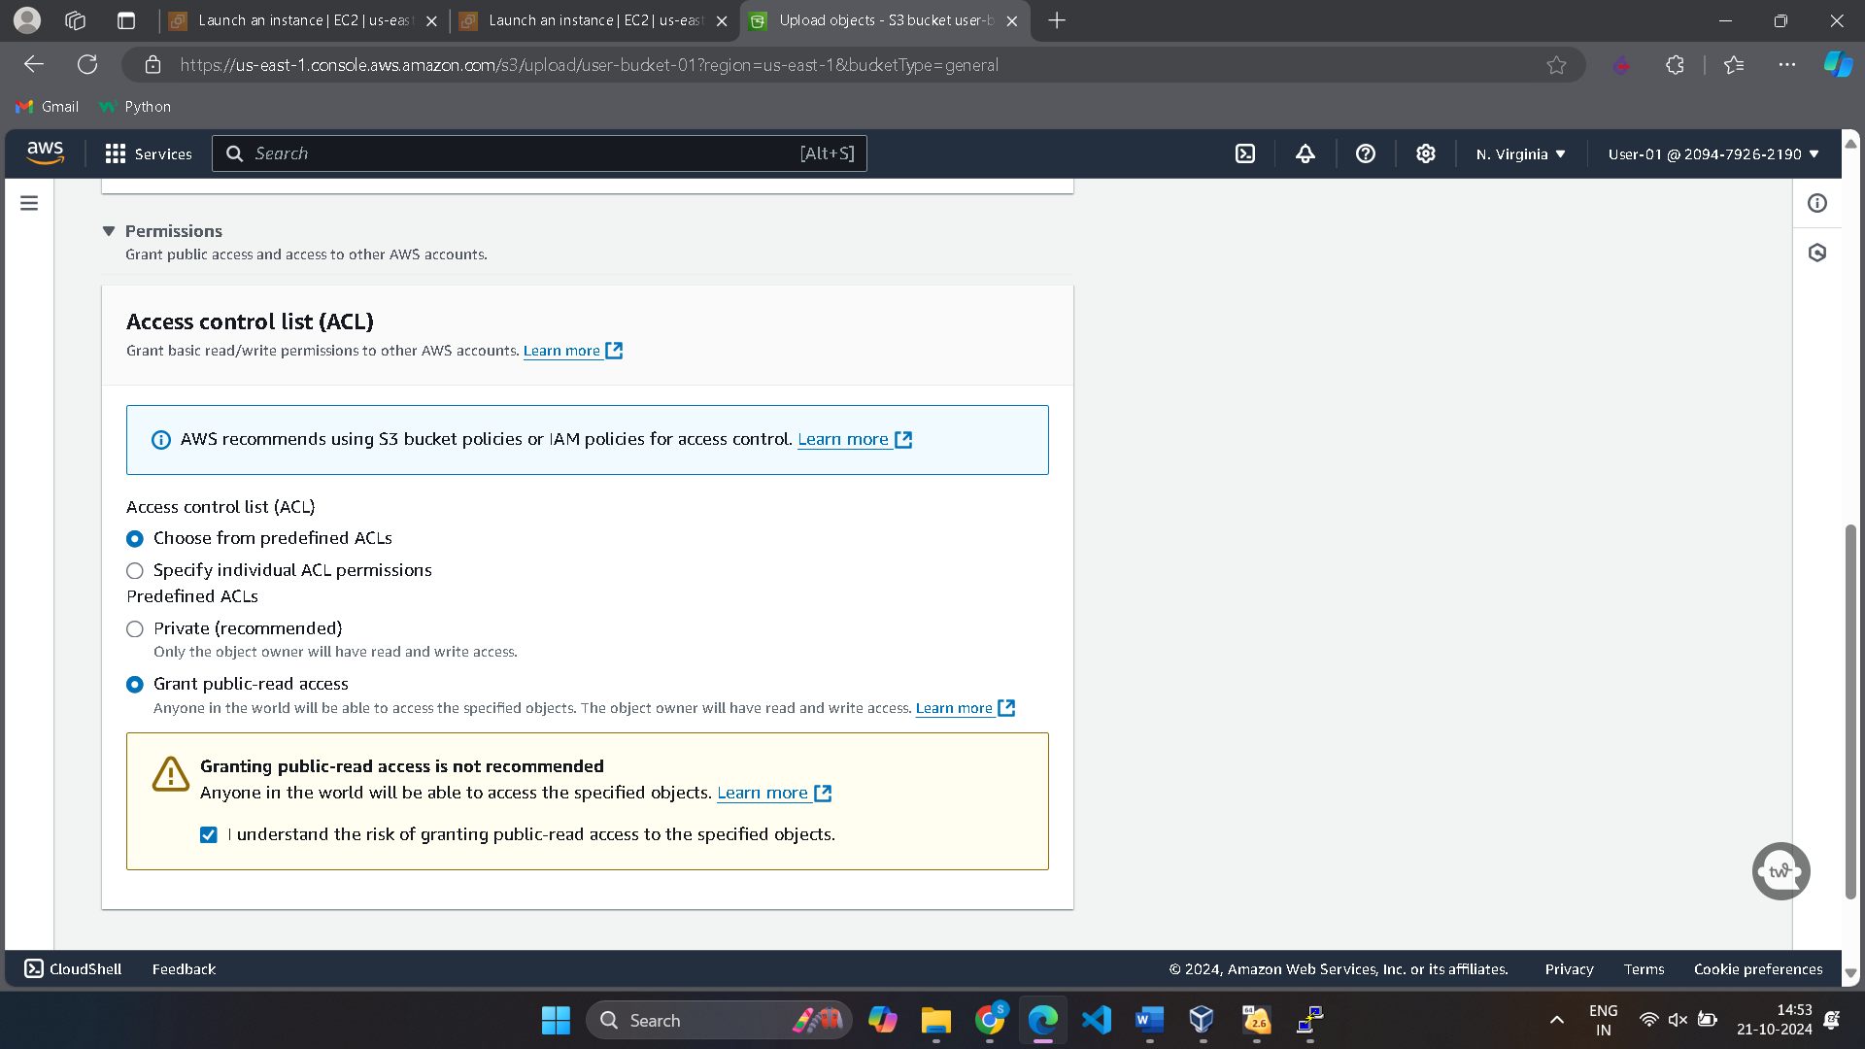

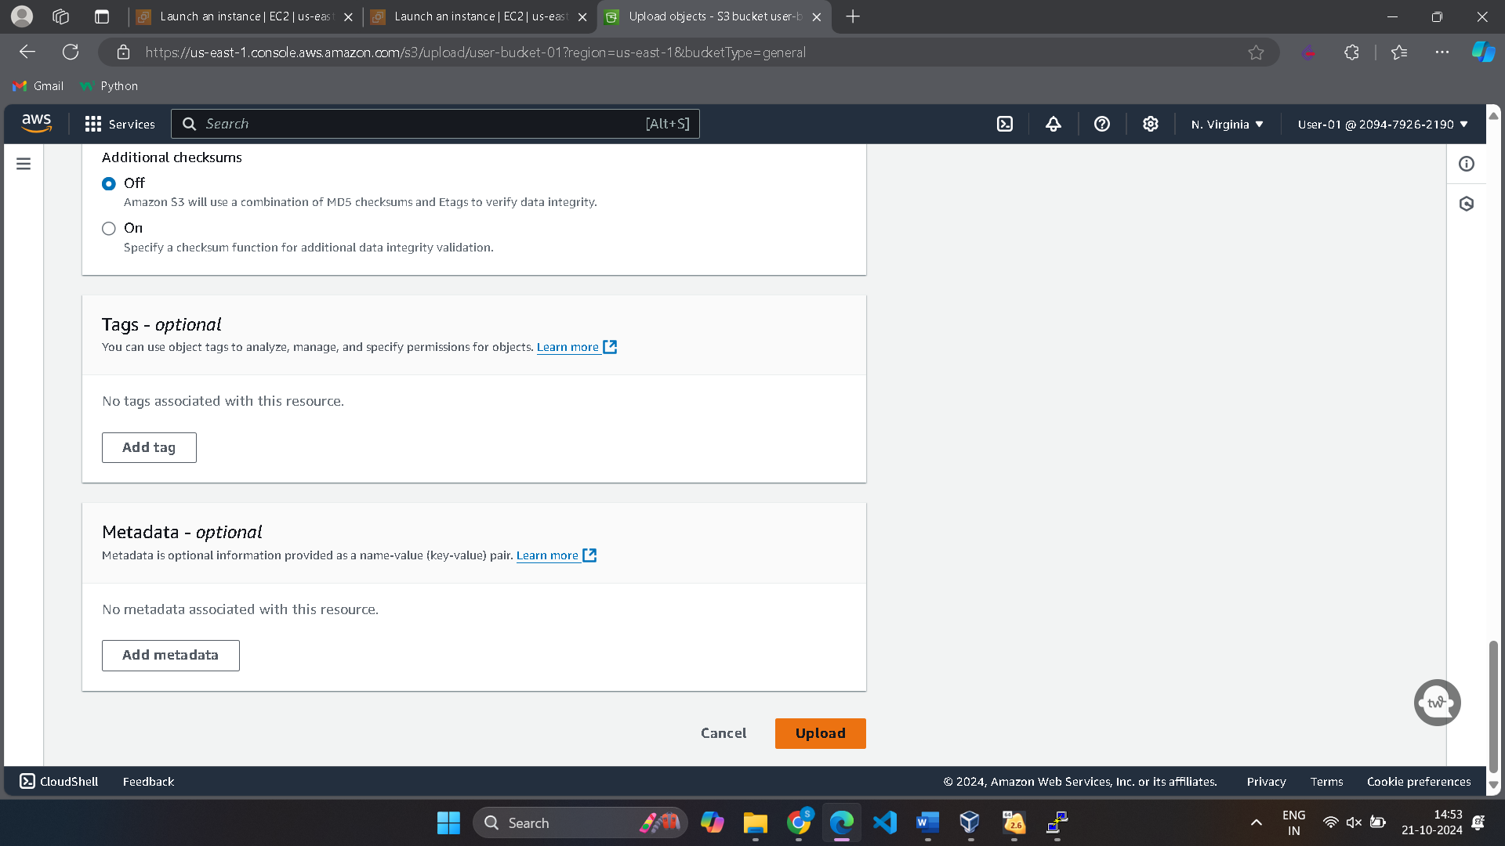

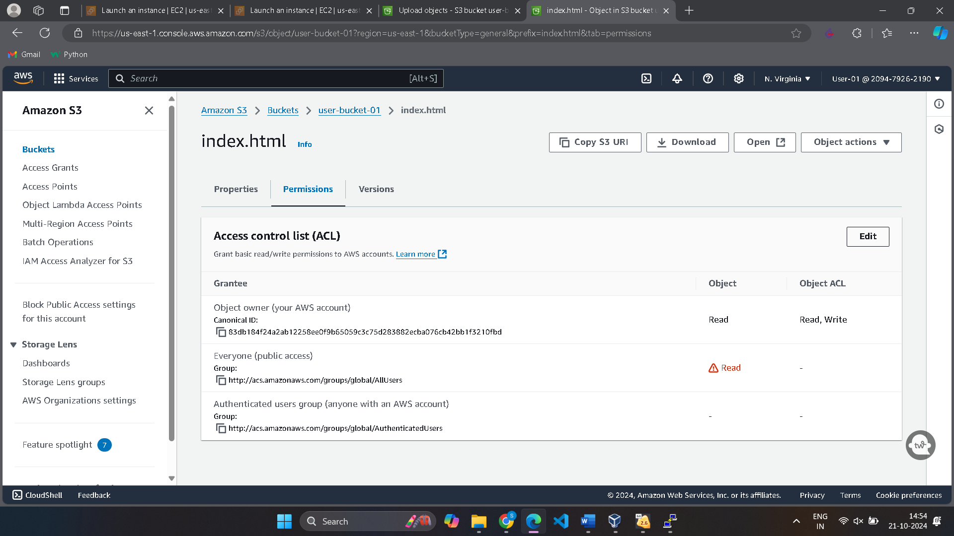

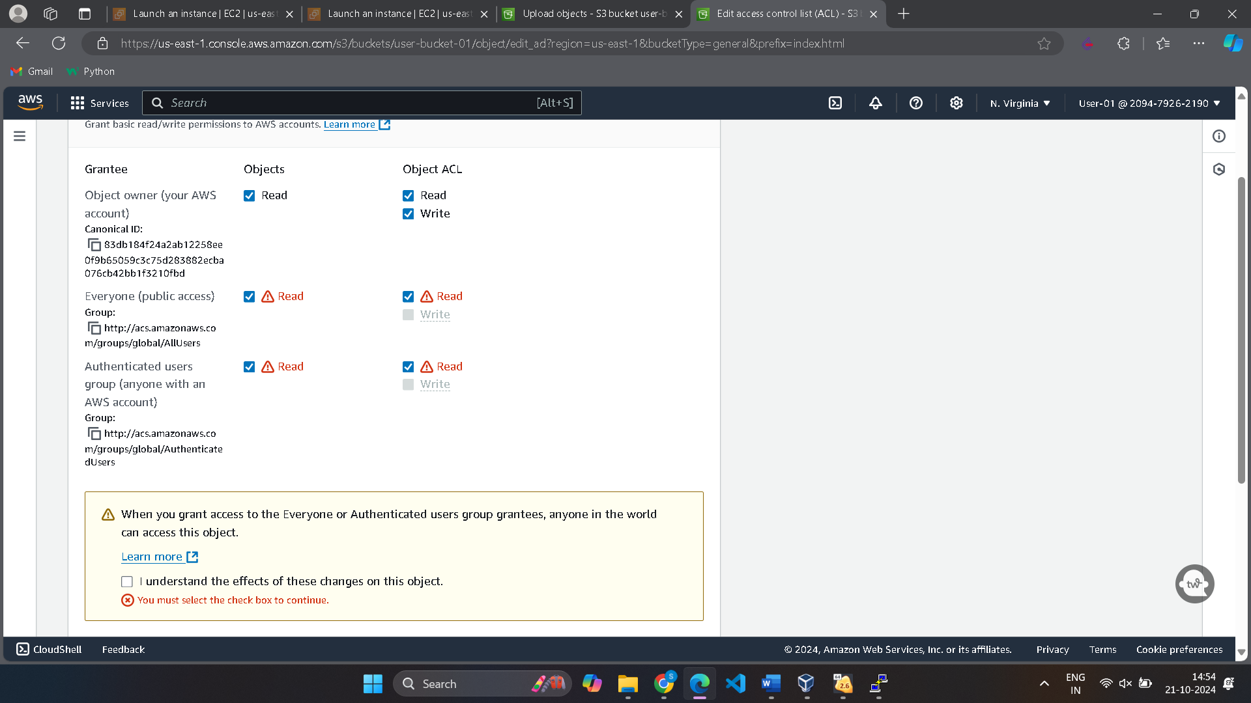

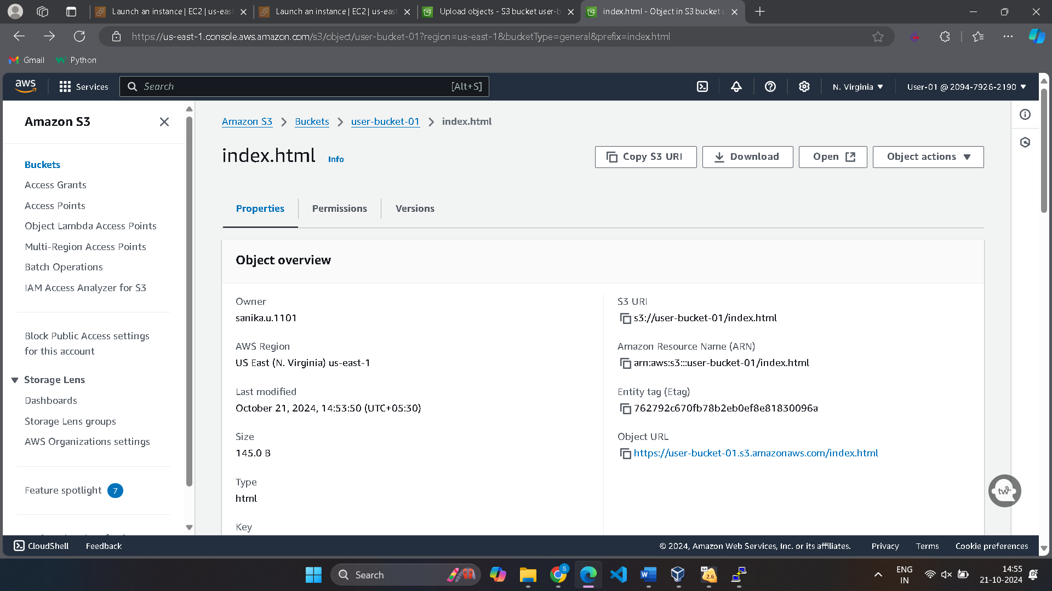

<https://user-bucket-01.s3.amazonaws.com/index.html>

